

KAUNAS UNIVERSITY OF TECHNOLOGY

FACULTY OF INFORMATICS

T120B166 Development of Computer Games and Interactive Applications

*In search of Light*

|  |
| --- |
| *IFF-6/8, Tadas Laurinaitis* |
|  |
| Date: 2019*.03.12* |

Kaunas, 2019

Tables of Contents

Tables of Images 4

Description of Your Game 5

Laboratory work #1 6

List of tasks 6

Solution 6

Task #1. *Add atleast 10 x 10 scenario elements* 6

Task #2. *Add 50 models to map* 6

Task #3. *Add 10 light sources to map* 7

Task #4. *Add atleast 10 sounds and 5 background music* 13

Task #5. *Add atleast 20 different materials* 13

Defence task 14

Laboratory work #2 17

List of tasks 17

Solution 18

Task #1. *Create a terrain and color it using 5 or more materials of your own design* 18

Task #2. *Create 5 trees of your own construction and seed them using terrain tools* 21

Task #3. *IMPORT a unique model and assign it to a third person character controller* 25

Task #4. *Add and animate 5 objects to your game maps* 25

Task #5. *Create 5 unique (non-factory) particle effects* 30

Task #6. *Add a CUSTOM SKYBOX* 34

Task #7. *Create 5 different physics materials and apply them in your project* 35

Task #8. *Assign an optimum collider based on the shape of the object for all 3D objects* 37

Task #9. *Add and animate 5 objects using PHYSICS, FORCE and TRIGGERS* 43

Task #10. *Set static flag to all immobile objects and measure batching performance* 47

Defence task 51

Laboratory work #3 54

Solution 55

Task #1. *Add a MENU system to your game* 55

Task #2. *Options* 58

Task #3. *Game must have a GUI* 63

Task #4. *Attack mechanics* 66

Task #5. *AI implementation* 68

Task #6. Health / powerup 73

Task #7. *Minimum of 5 spawn points* 75

Task #8. *Scoring system* 75

Task #9. *Game over condition* 76

Task #10. *High scores must have rankings and should not disappear after reloading* 76

Literature list 76

ANNEX 78

# **Tables of Images**

Figure 1 Screenshot #1 6

Figure 2. Models #1 6

Figure 3. Light #1 7

Figure 4 Light #2 8

Figure 5 Light #3 8

Figure 6 Light #4 9

Figure 7 Light #5 9

Figure 8 Light #6 10

Figure 9 Light #7 10

Figure 10 Light #8 11

Figure 11 Light #9 12

Figure 12 Light #10 12

Figure 13. Screenshot #3 13

Figure 14 Screenshot #1 13

Figure 15 Materials #1 13

Figure 16 Materials #2 14

Figure 17 Materials #3 14

Figure 18 Defense task completed 14

Figure 19 Defense task light 15

Figure 20 Defense task light #2 15

Figure 21 Defense task light settings 16

# **Description of Your Game**

Description of Your Game.

1. 3D or 2D? *3D.*
2. What type is your game? *A 3rd person adventure RPG.*
3. What genre is your game? *A 3rd person adventure RPG.*
4. Platforms (mobile, PC or both?) *PC.*
5. Scenario Description. *A spaceship crashes on a distant unknown planet on which the people are still living in the medieval times. The Survivor has to explore the planet, meet the locals, aid them in their quests and find a way to get back to his own home planet.*

**Laboratory work #1**

**List of tasks** (main functionality of your project)

1. Add 50 models to map #1
2. Add 10 Light sources to map #2
3. Add 10 sound and 5 background music effects #3
4. Create atleast 10x10 scenario elements
5. Use atleast 20 different materials

# **Solution**

## **Task #1. *Add atleast 10 x 10 scenario elements***

Description of the implementation (3-5 sentences).  *I added a map with a size over 10 x 10 scenario elements to my map.*

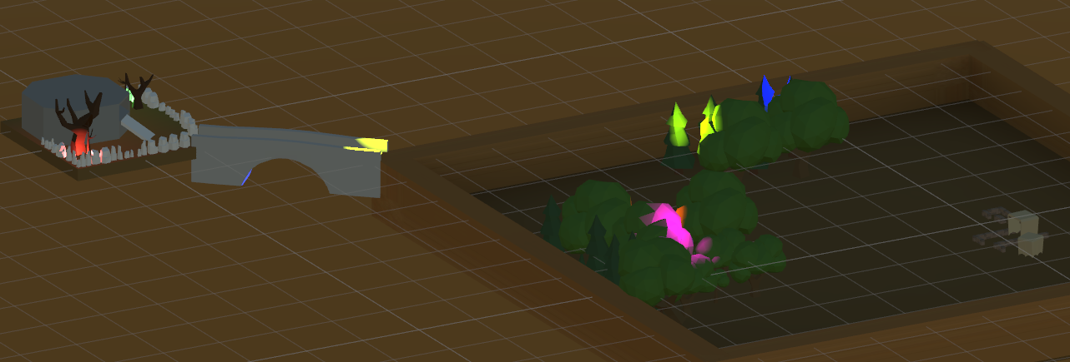

Figure 1 Screenshot #1

## **Task #2. *Add 50 models to map***

Description of the implementation (3-5 sentences).  *I added over 50 models to my map, some of these were made by me and some of these were downloaded from free asset stores like itch.io*



Figure 2. Models #1

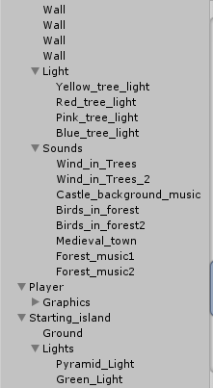

## **Task #3. *Add 10 light sources to map***

Description of the implementation (3-5 sentences). *I added 10 different light sources to my map. All of these light sources are point lights with different intensity and colors.*

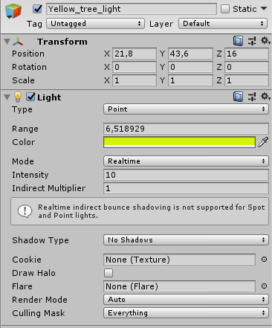

Figure 3. Light #1

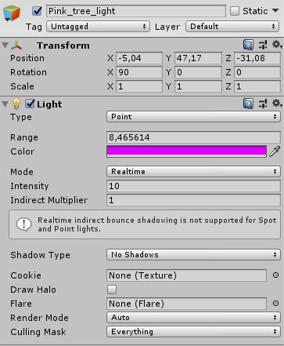

Figure 4 Light #2

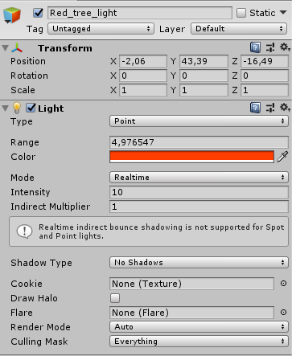

Figure 5 Light #3

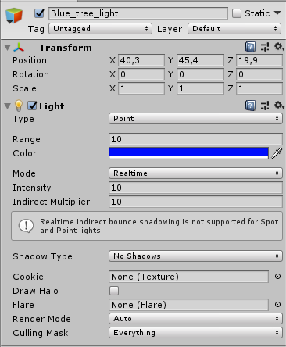

Figure 6 Light #4

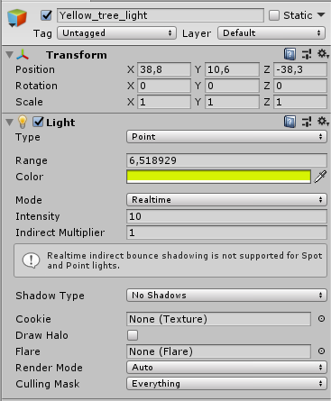

Figure 7 Light #5

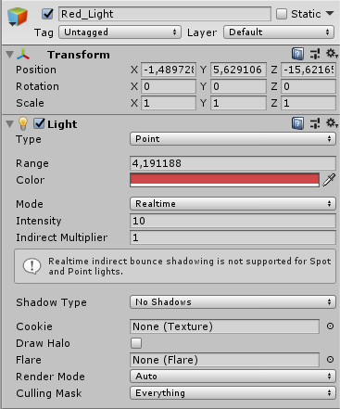

Figure 8 Light #6

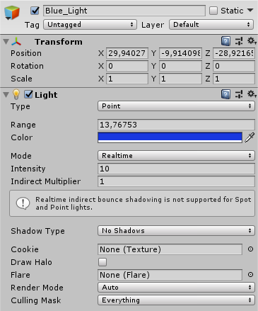

Figure 9 Light #7

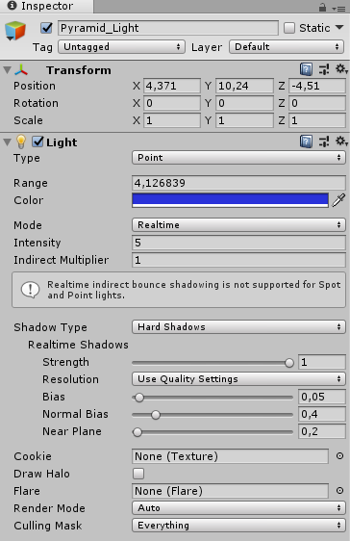

Figure 10 Light #8

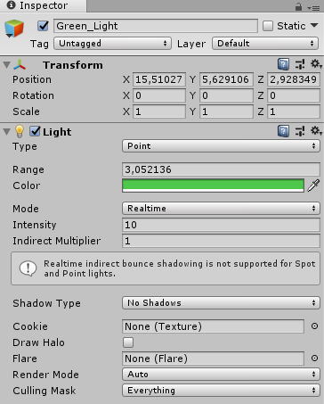

Figure 11 Light #9

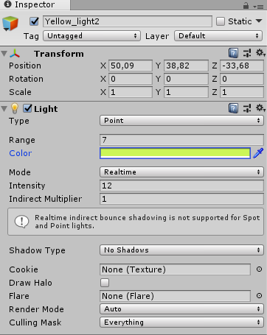

Figure 12 Light #10

## **Task #4. *Add atleast 10 sounds and 5 background music***

Description of the implementation (3-5 sentences). *Firstly I searched for royalty free sound effects on different sites, then I downloaded some background music. After that, I created some audio player components and added them to my map.*

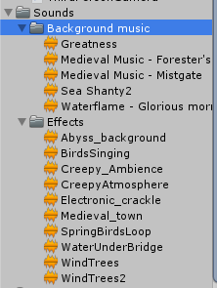

Figure 13. Screenshot #3

## **Task #5. *Add atleast 20 different materials***

Description of the implementation (3-5 sentences).  *I added around 20 different materials to my map and placed them on different objects*



Figure 14 Screenshot #1

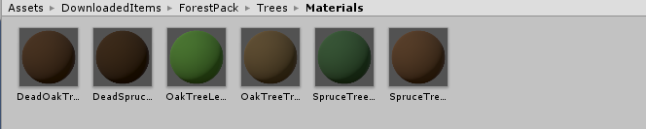

Figure 15 Materials #1

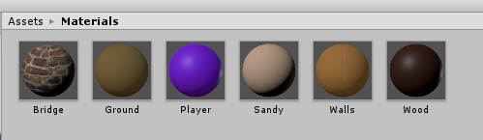

Figure 16 Materials #2

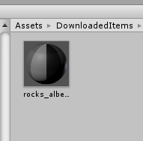

Figure 17 Materials #3

# **Defence task**

Color a plane into two areas with two different lights.

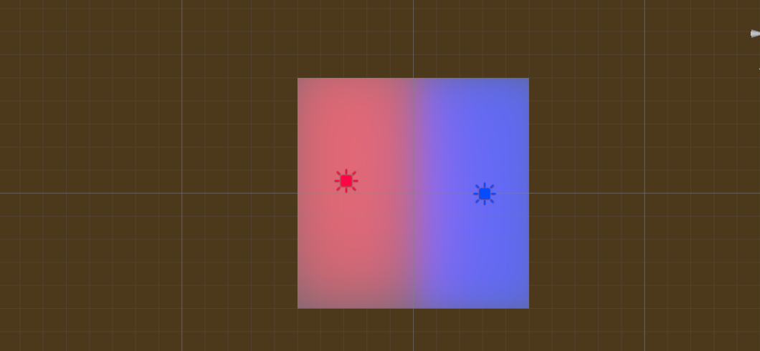

Figure 18 Defense task completed

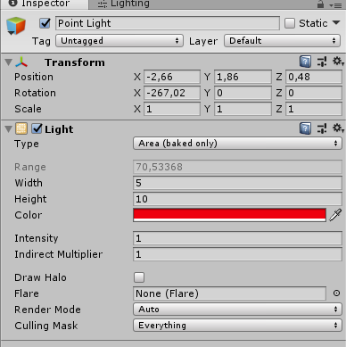

Figure 19 Defense task light

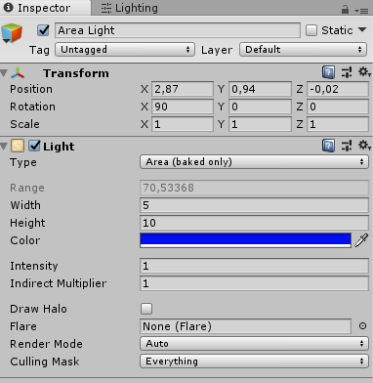

Figure 20 Defense task light #2

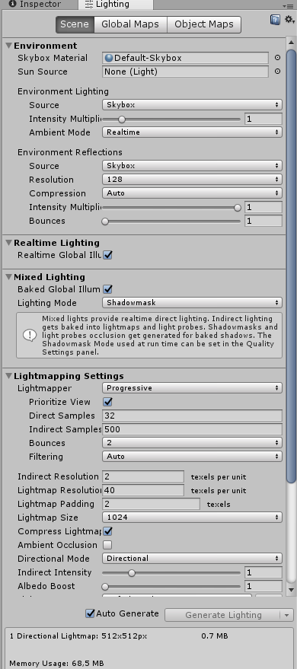

Figure 21 Defense task light settings

# **Laboratory work #2**

List of tasks (main functionality of your project)

1. Create a terrain and color it using 5 or more materials of your own design;
2. Create 5 trees of your own construction and seed them using terrain tools;
3. IMPORT a unique model and assign it to a third person character controller;
4. Add and animate 5 obejcts to your game maps
5. Create 5 unique (non-factory) particle effects (fire, portal, etc.);
6. Add a CUSTOM SKYBOX
7. Create 5 different physics materials and apply them in your project
8. Assign an optimum collider based on the shape of the object for all 3D objects imported in the first laboratory work;
9. Add and animate 5 objects using PHYSICS, FORCE and TRIGGERS to your game maps (traps, falling objects, moving doors, etc.)
10. Set static flag to all immobile objects and measure batching performance;
11. Try deferred vs forward rendering and measure performance for both;
12. Bake a lightmap for your scene and measure performance;
13. Optimize all textures depending on their parameters and measure graphical memory load;
14. Try hard vs soft shadows, different quality settings and measure the performance;

# **Solution**

## **Task #1. *Create a terrain and color it using 5 or more materials of your own design***

Description of the implementation (3-5 sentences).  *Firstly, I added a new terrain objects. Then I reshaped it, added some mountains and painted it with textures using the default tools provided in unity editor.*

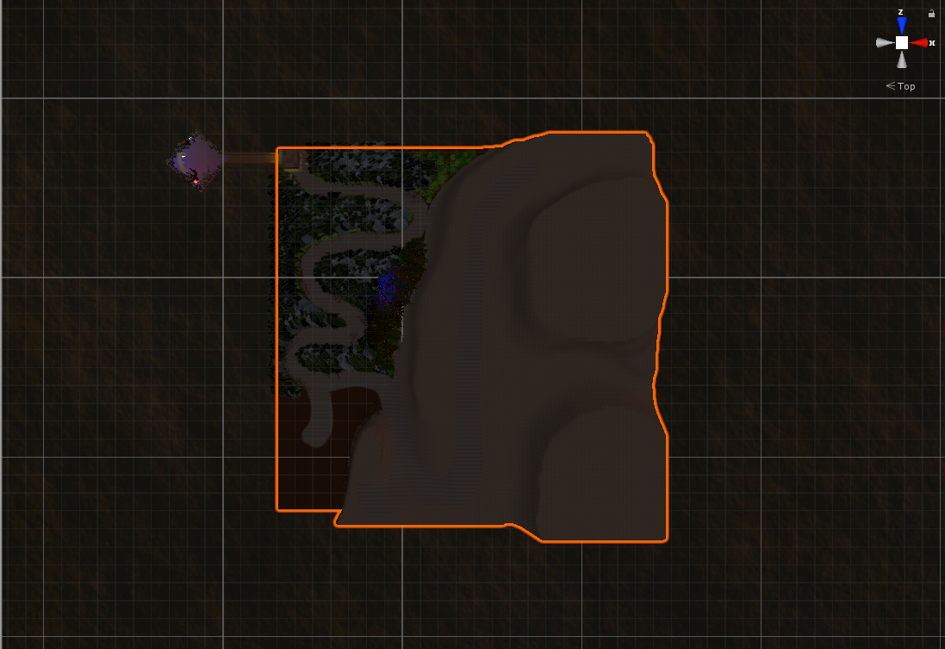

Figure 22 Screenshot of terrain from above

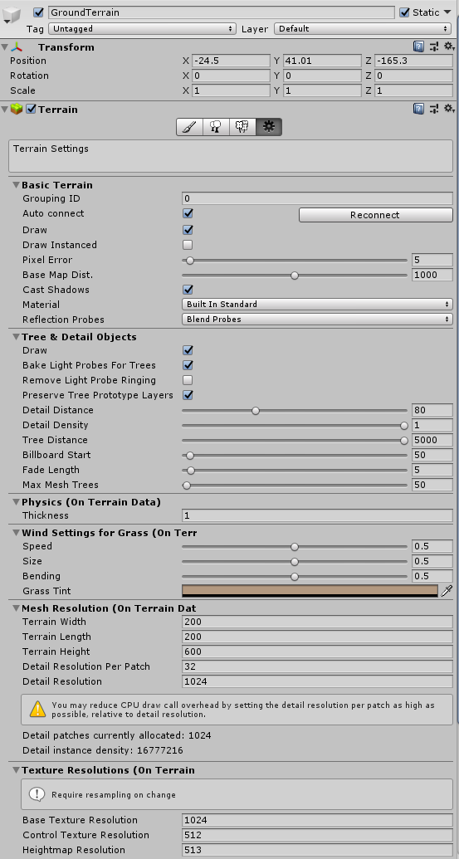

Figure 23 Terrain parameters

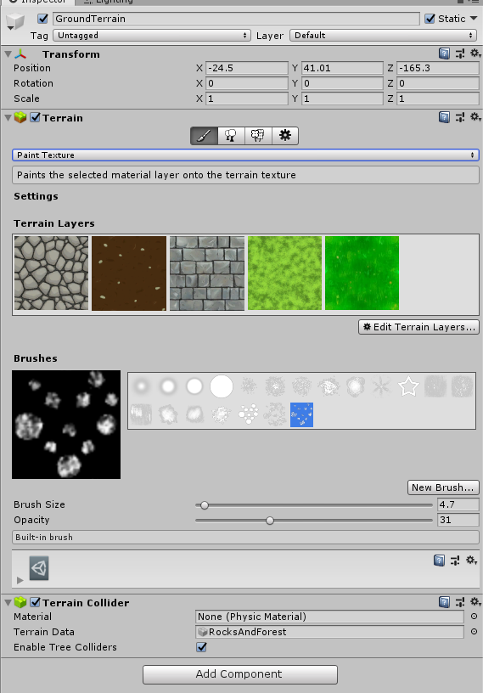

Figure 24 Materials used to colour the terrain

## **Task #2. *Create 5 trees of your own construction and seed them using terrain tools***

Description of the implementation (3-5 sentences).  *Firstly, I created 5 unique trees, added some branches and leaves to each one of them, then added a few different materials and capsule colliders to all of them. Then using the terrain feature called “Paint trees”, I quickly added a lot of tress to my terrain to make it look more live.*

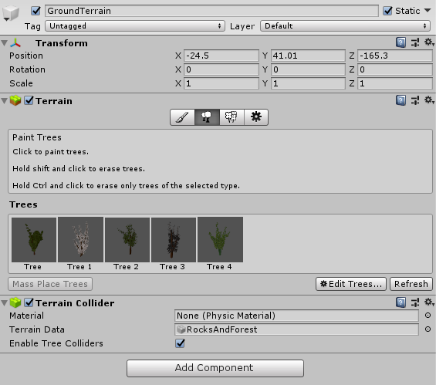

Figure 25 Trees used in Tree painting

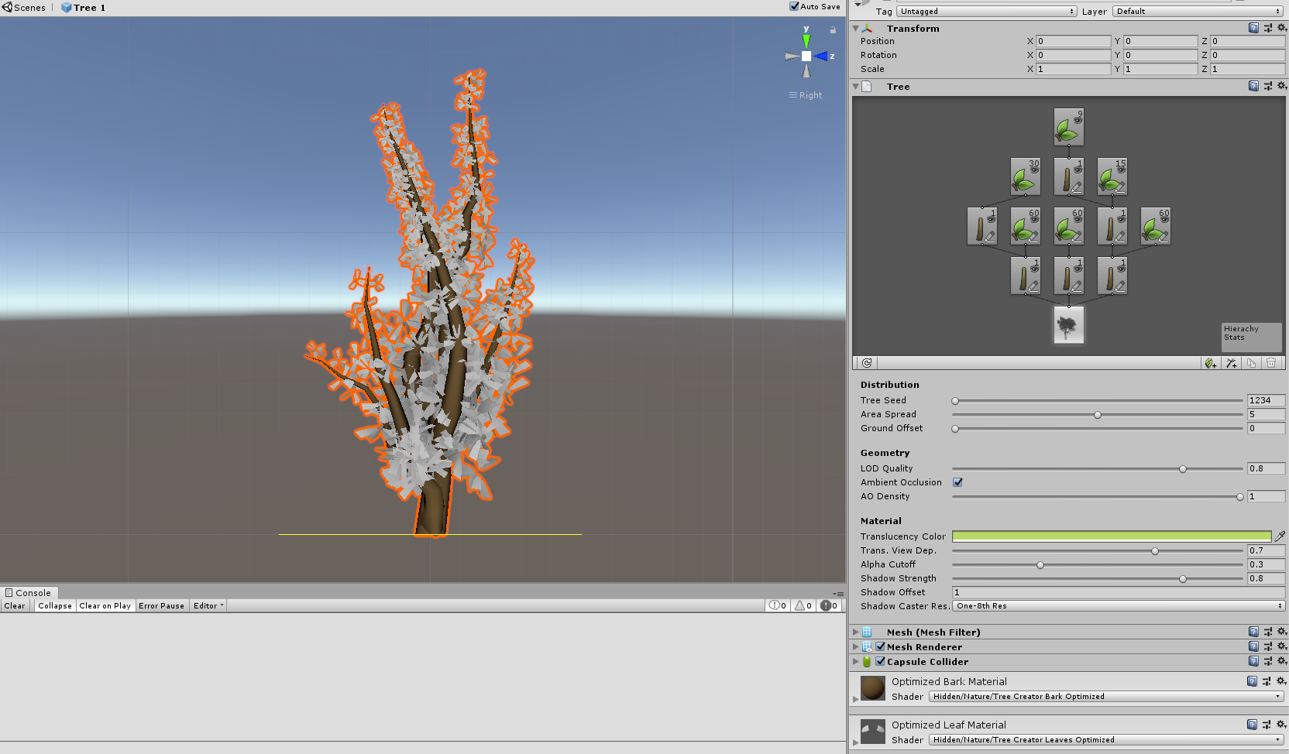

Figure 26 Structure of tree #1

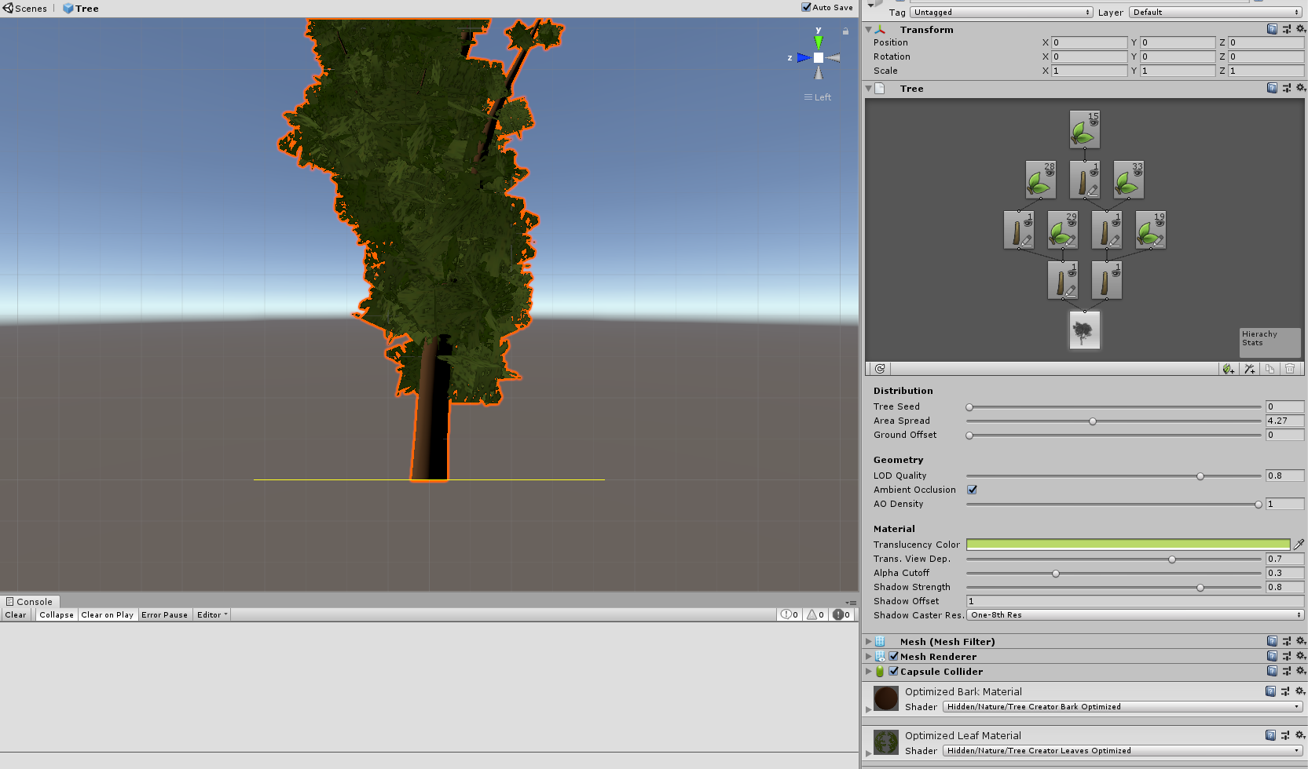

Figure 27 Structure of tree #2

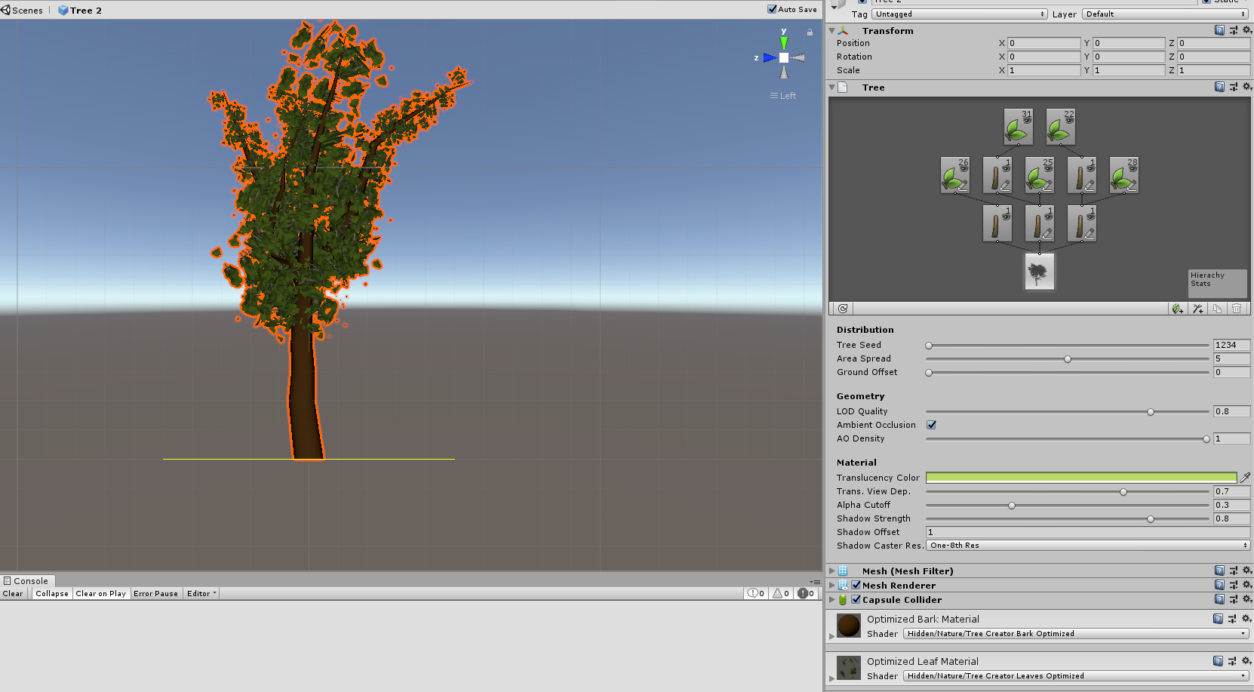

Figure 28 Structure of tree #3

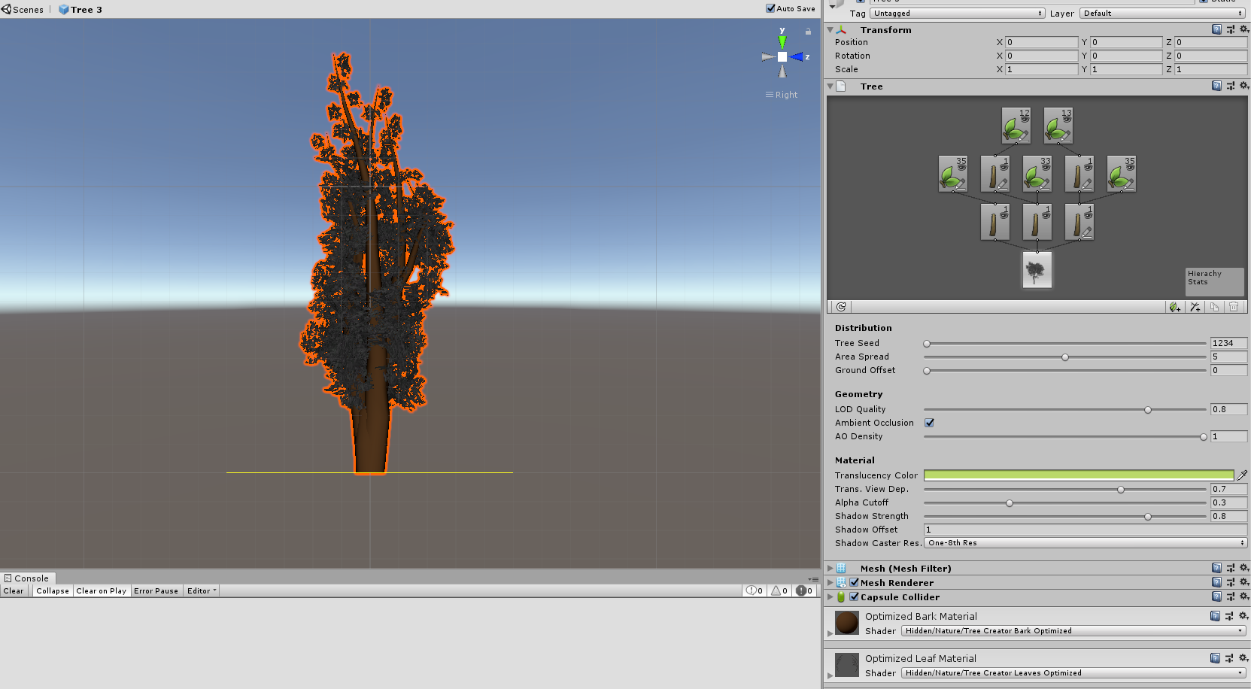

Figure 29 Structure of tree #4

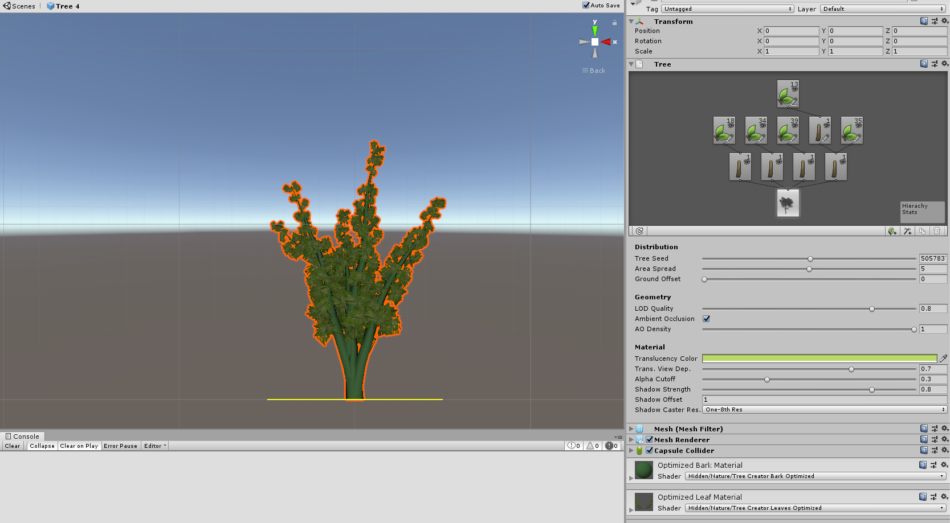

Figure 30 Structure of tree #5

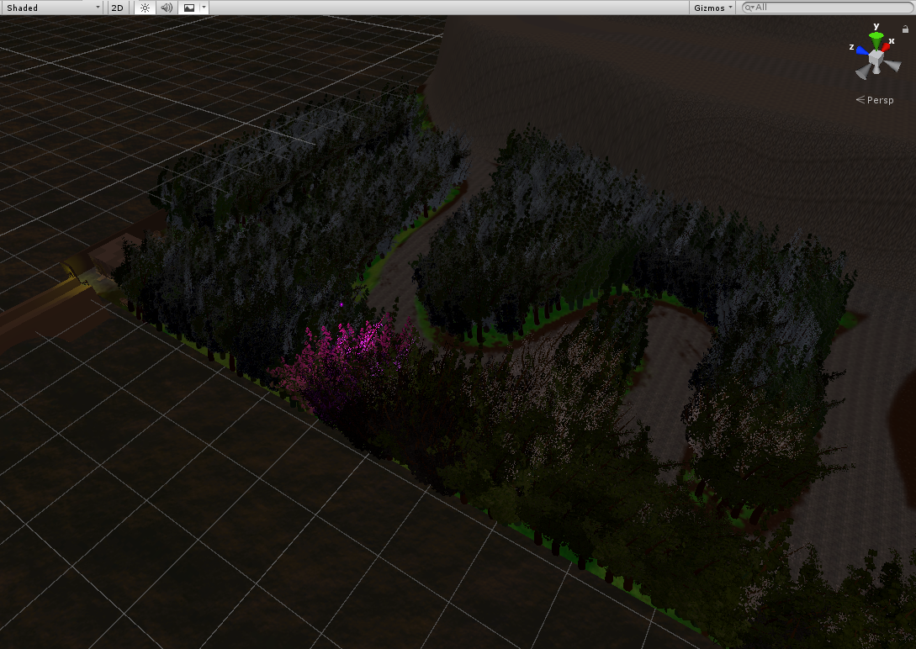

Figure 31 Forest created using Paint trees tool

## **Task #3. *IMPORT a unique model and assign it to a third person character controller***

Description of the implementation (3-5 sentences).  *Firstly, I downloaded Blood mage character from unity asset store. Then I imported it, attached rigid body, third person control and third person character scripts, and capsule collider components to it and checked if the bone structure was working as expected.*

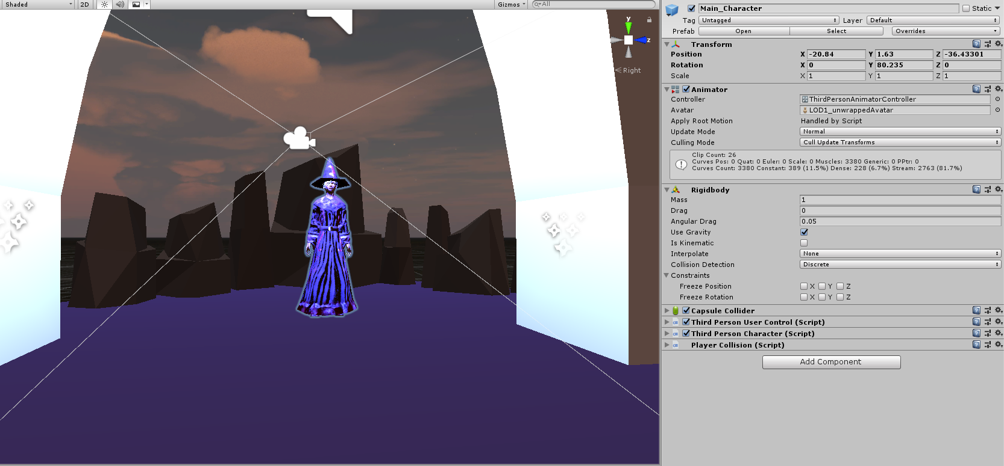

Figure 32 Properties of the main character

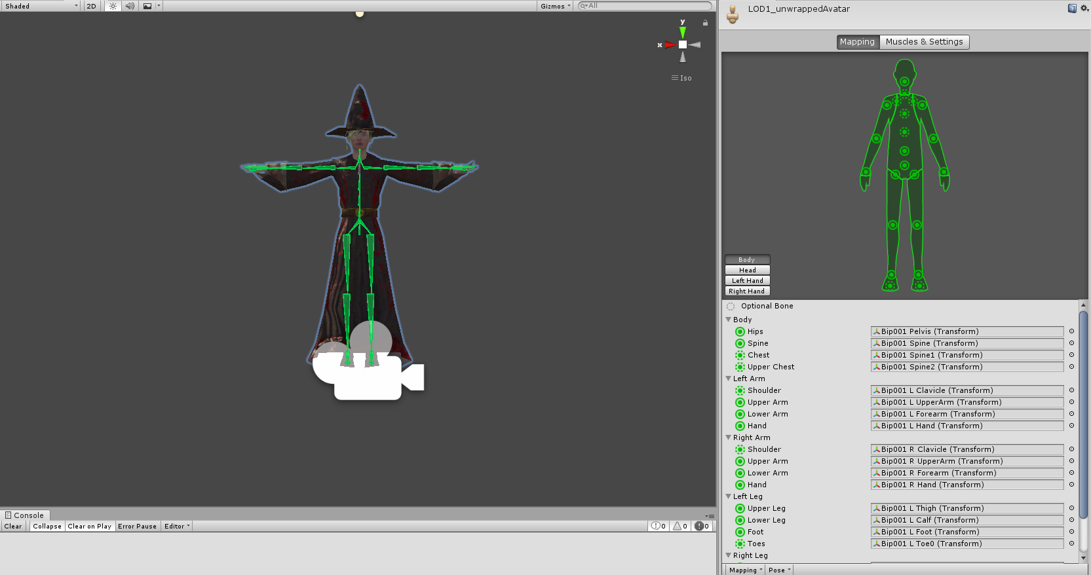

Figure 33 Bone structure of main character

## **Task #4. *Add and animate 5 objects to your game maps***

Description of the implementation (3-5 sentences).  *I added some objects from asset store, attached animators and animation controllers to all of them and then created 5 animations.*

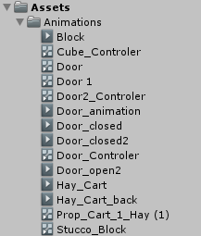

Figure 34 Animation folder

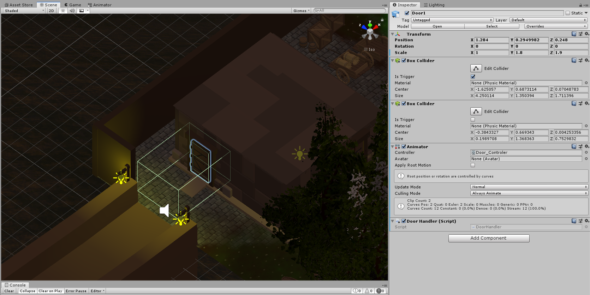

Figure 35 Animated object

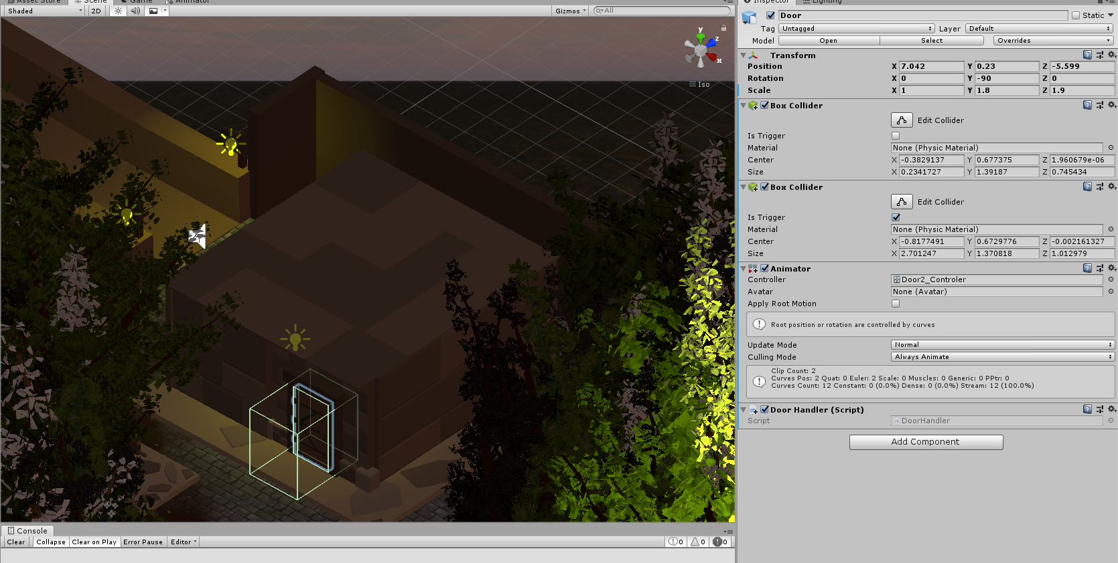

Figure 36 Animated object

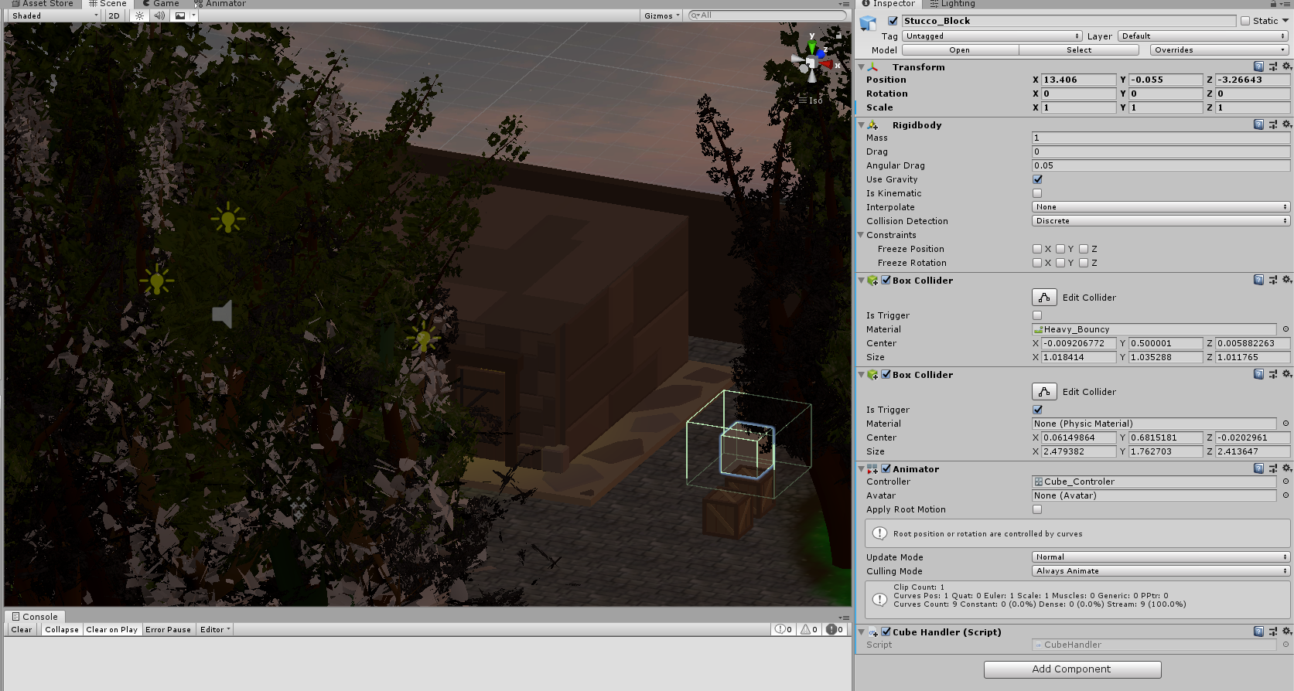

Figure 38 Animated object

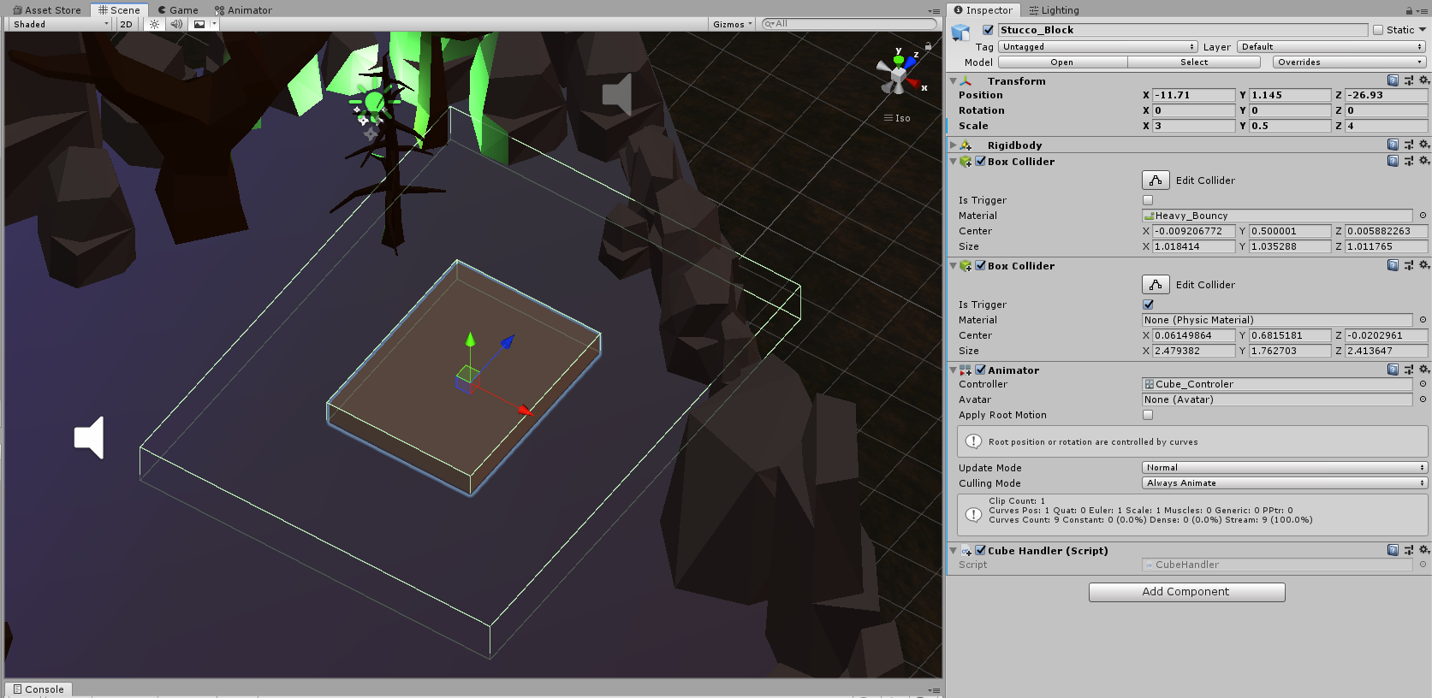

Figure 39 Animated object

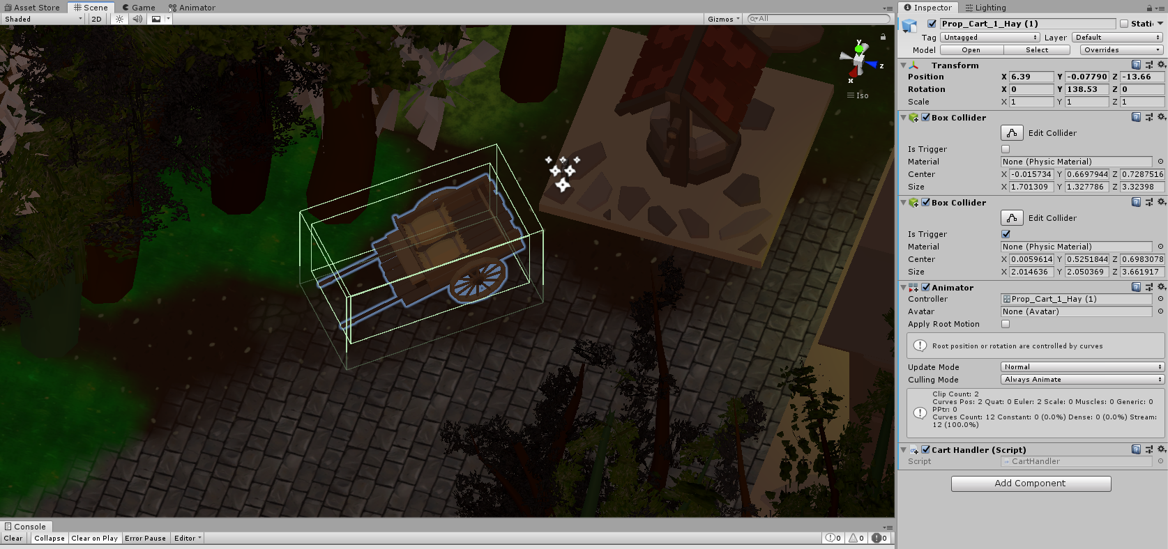

Figure 40 Animated object

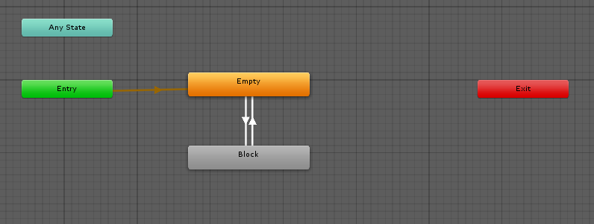

Figure 41 Block animation controller

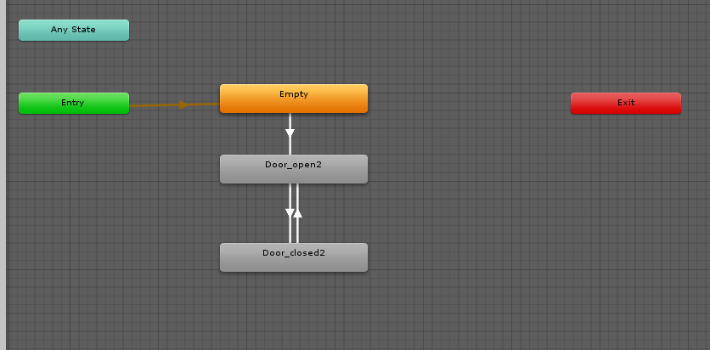

Figure 42 Door 2 animation controller

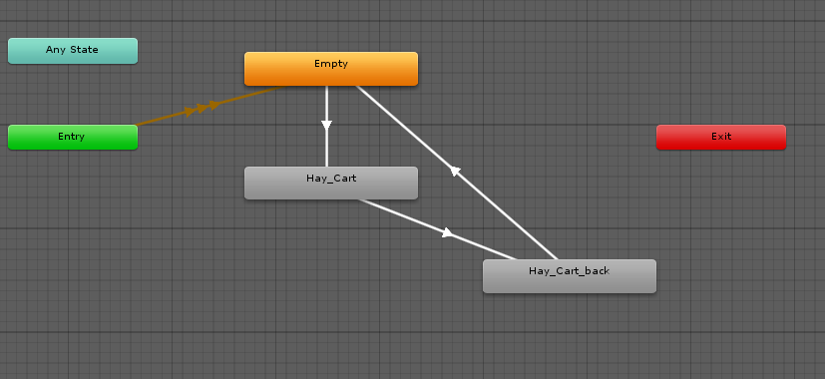

Figure 43 Hay cart animation controller

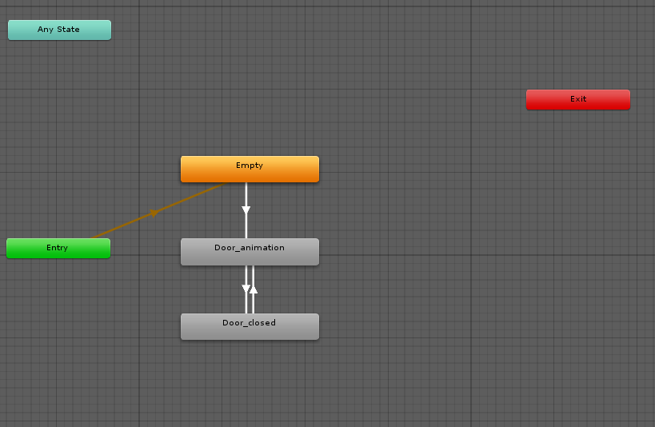

Figure 44 Door animation controller

## **Task #5. *Create 5 unique (non-factory) particle effects***

Description of the implementation (3-5 sentences).  *I created 5 unique particle effects and added them to my map*

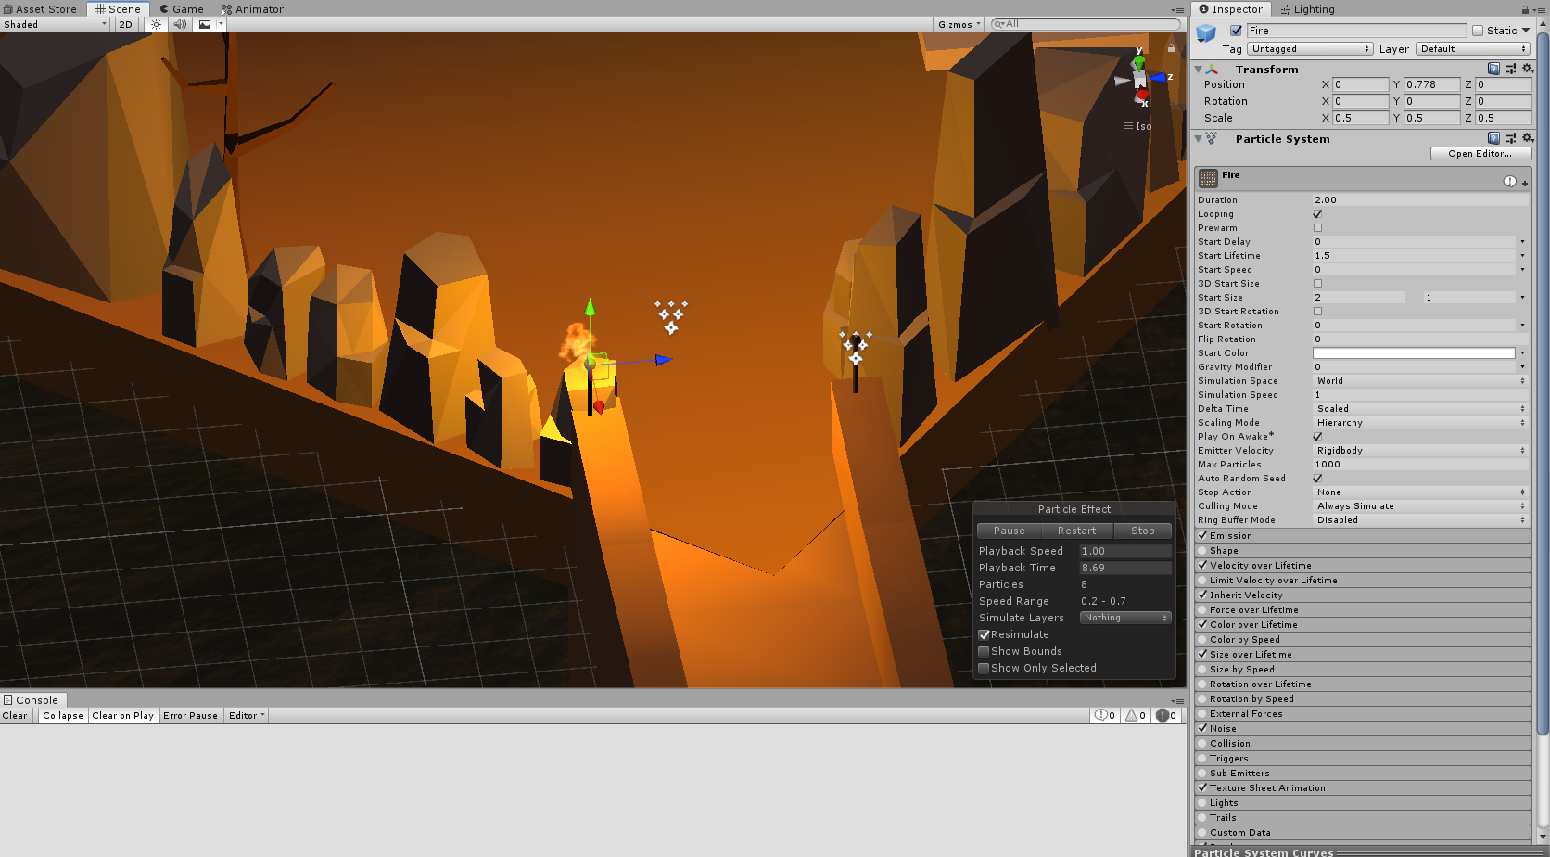

Figure 45 Particle effect #1

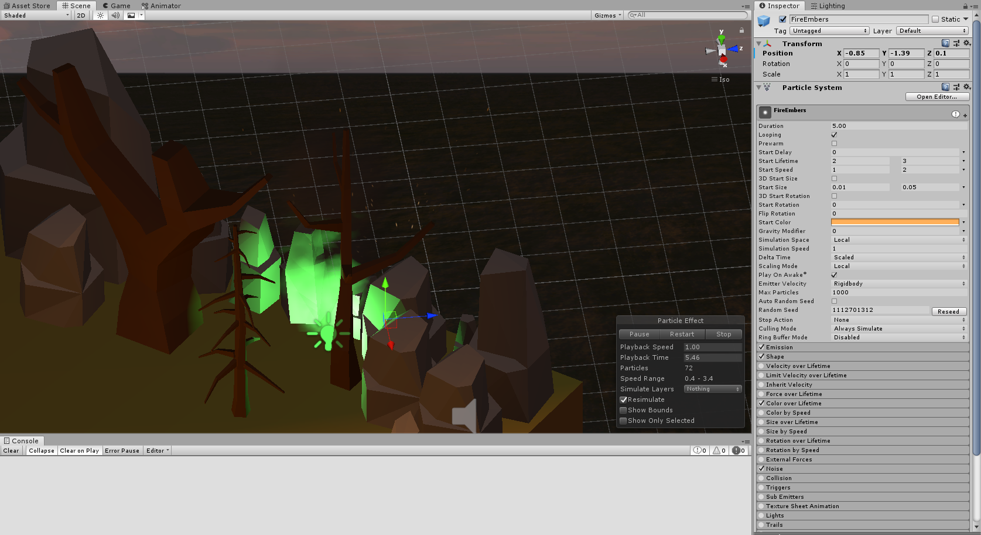

Figure 46 Particle effect #2

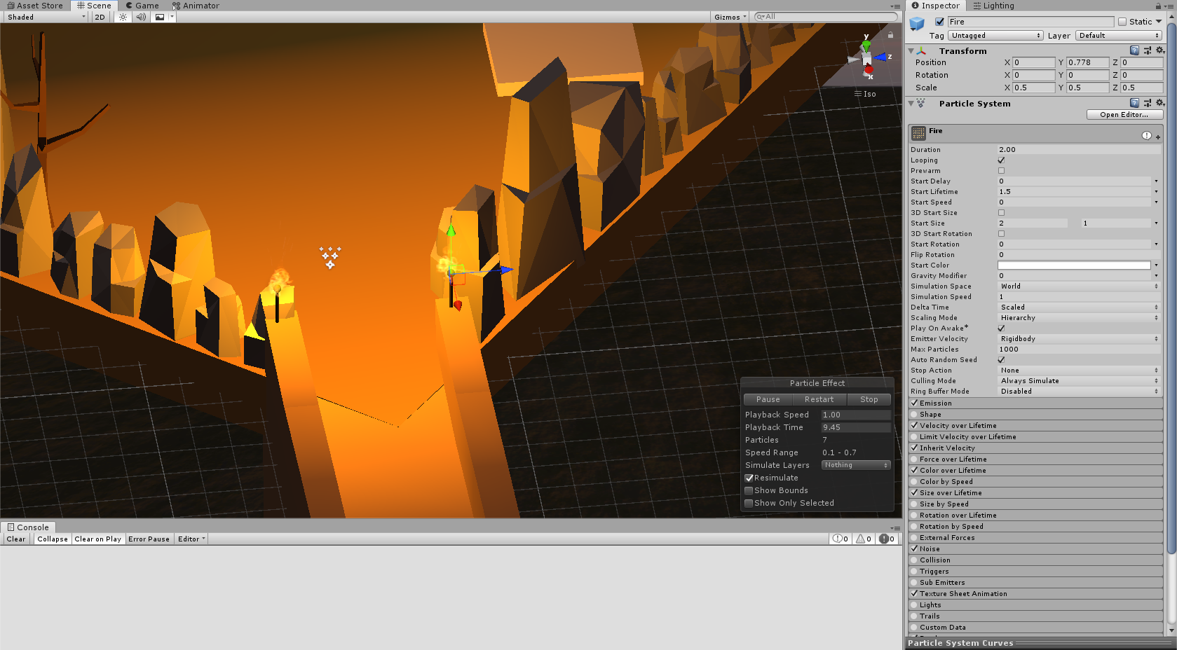

Figure 47 Particle effect #3

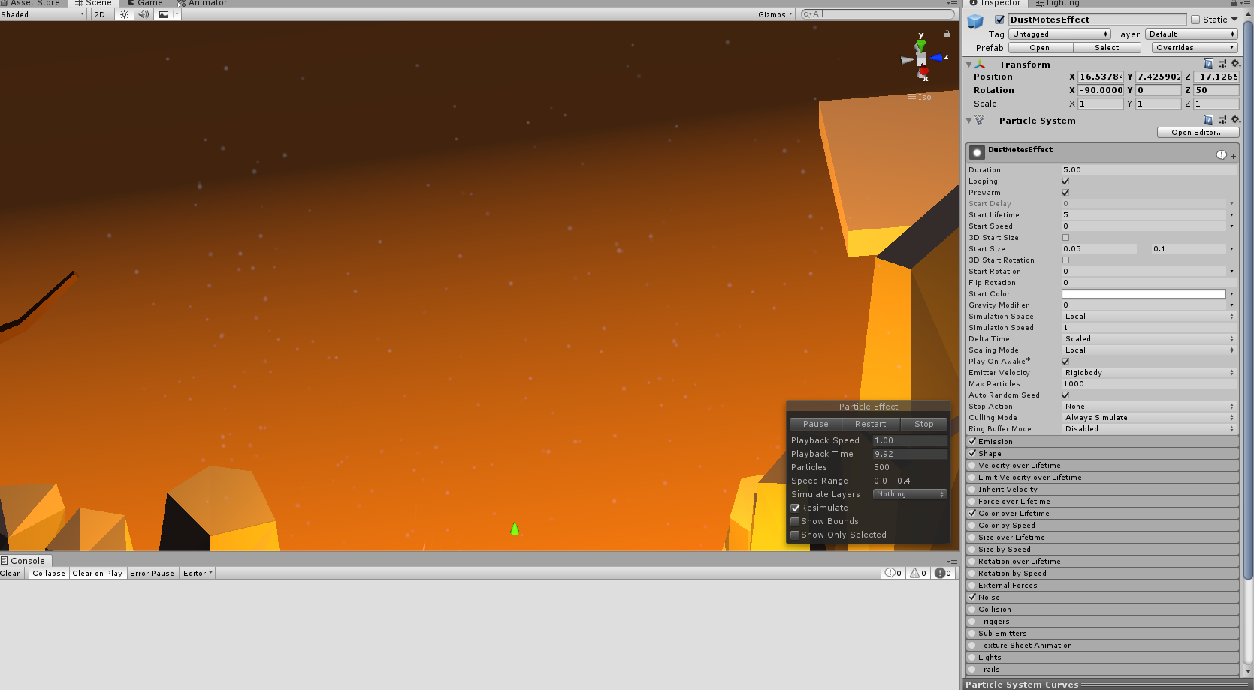

Figure 48 Particle effect #4

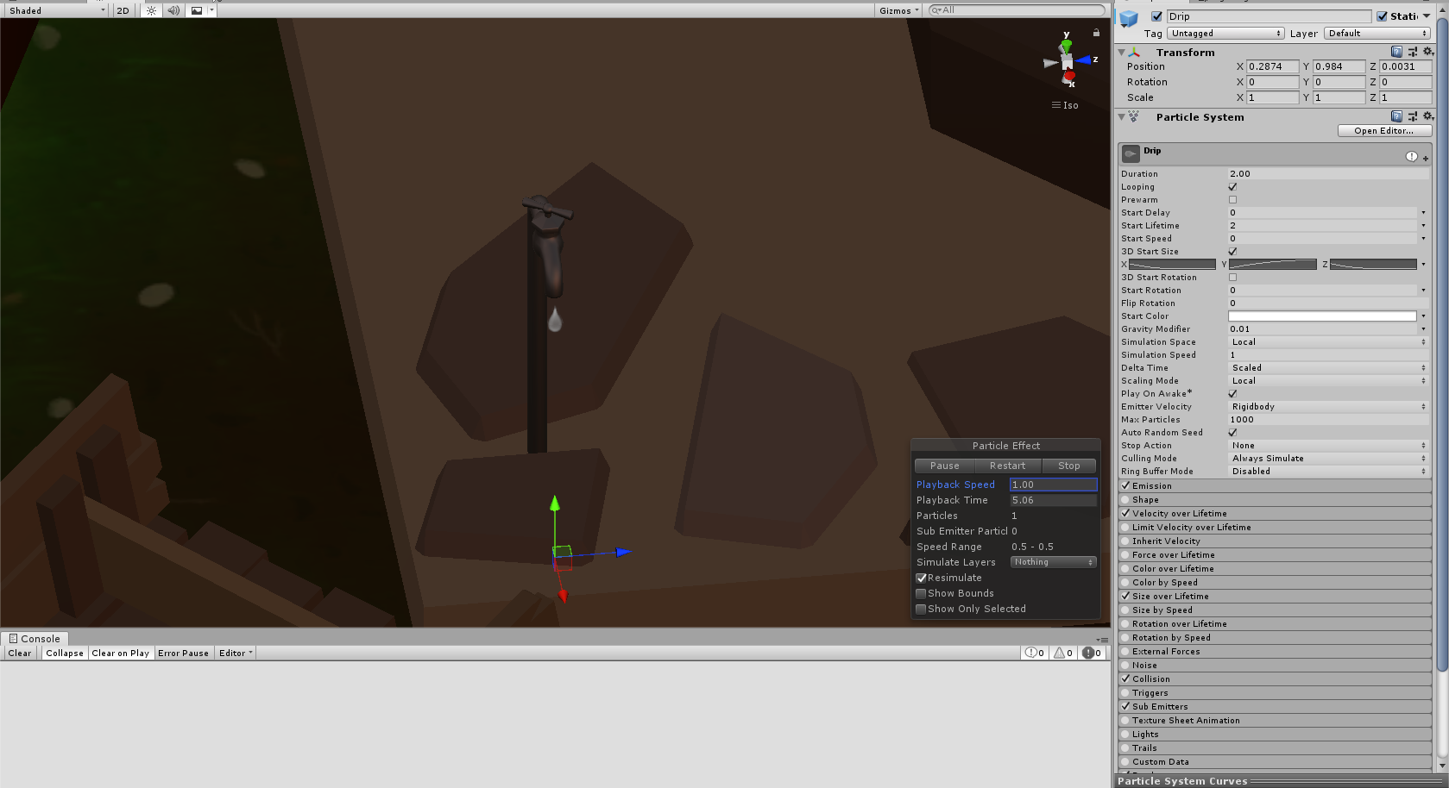

Figure 49 Particle effect #5

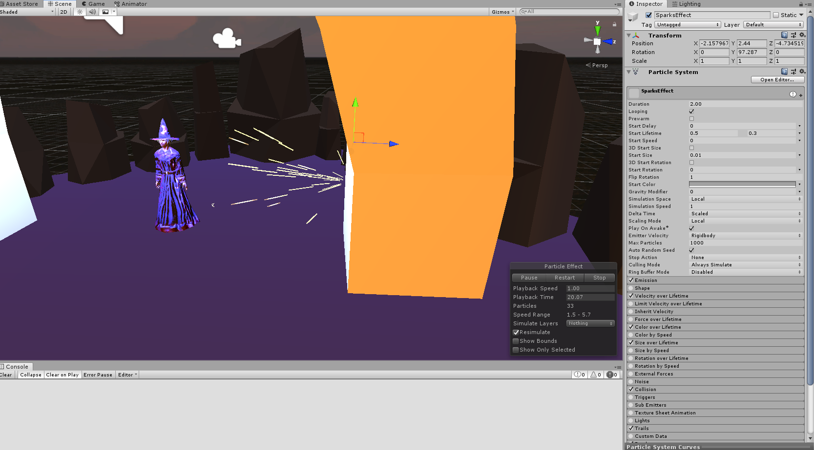

Figure 49 Particle effect #6

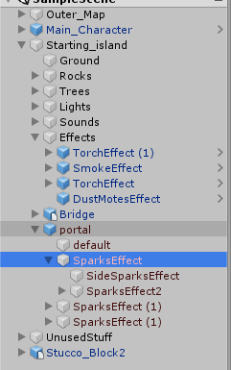

Figure 50 Particle effects

## **Task #6. *Add a CUSTOM SKYBOX***

Description of the implementation (3-5 sentences).  *I downloaded a cube shaped picture and applied it to skybox material.*

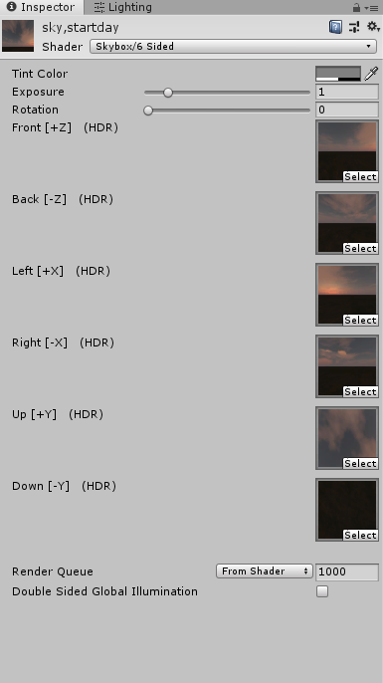

Figure 51 Custom Skybox

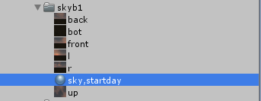

Figure 52 Custom Skybox

## **Task #7. *Create 5 different physics materials and apply them in your project***

Description of the implementation (3-5 sentences).  *I created 5 different physics materials with different properties and applied them to the objects in my scene.*

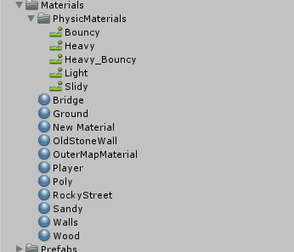

Figure 53 Unique physics materials

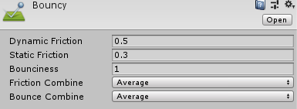

Figure 54 Bouncy physics material

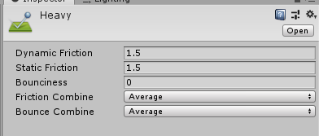

Figure 55 Heavy physics material

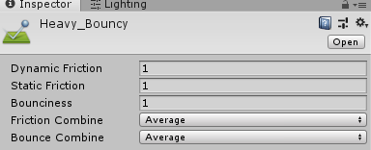

Figure 56 Heavy_Bouncy physics material

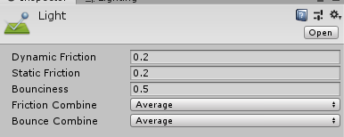

Figure 56 Light physics material

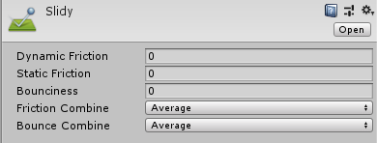

Figure 57 Slidy physics material

## **Task #8. *Assign an optimum collider based on the shape of the object for all 3D objects***

Description of the implementation (3-5 sentences).  *I assigned various colliders to many different objects.*

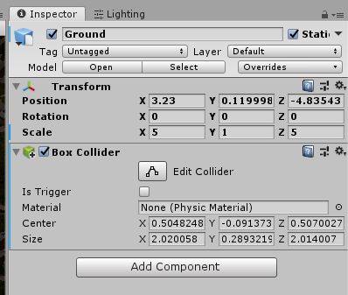

Figure 58 Defense task light settings

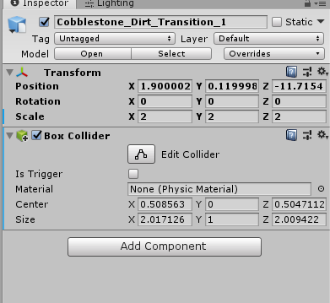

Figure 59 Defense task light settings

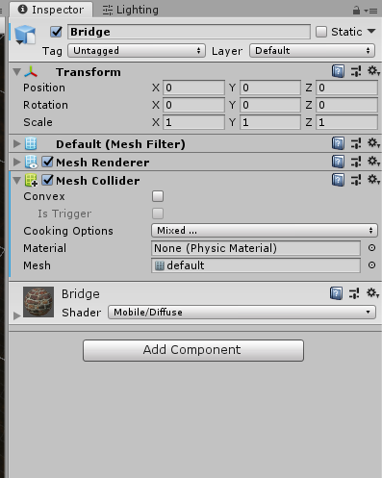

Figure 60 Defense task light settings

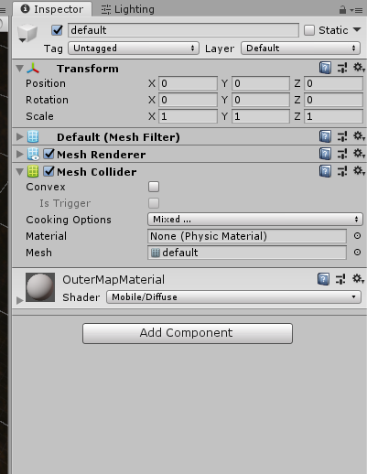

Figure 61 Defense task light settings

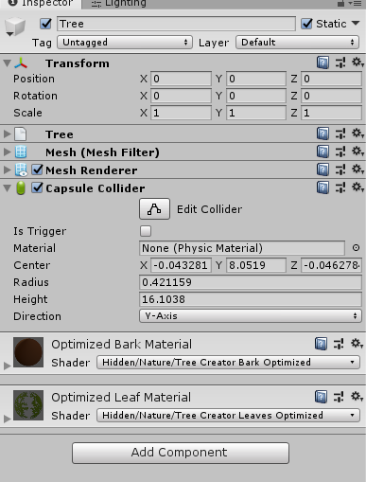

Figure 62 Defense task light settings

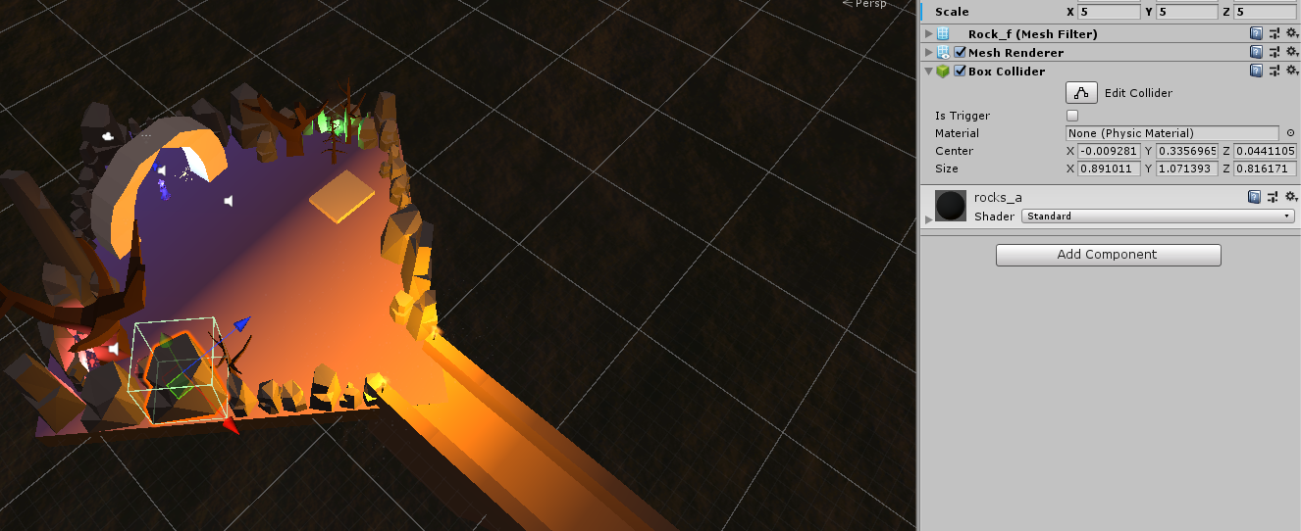

Figure 63 Defense task light settings

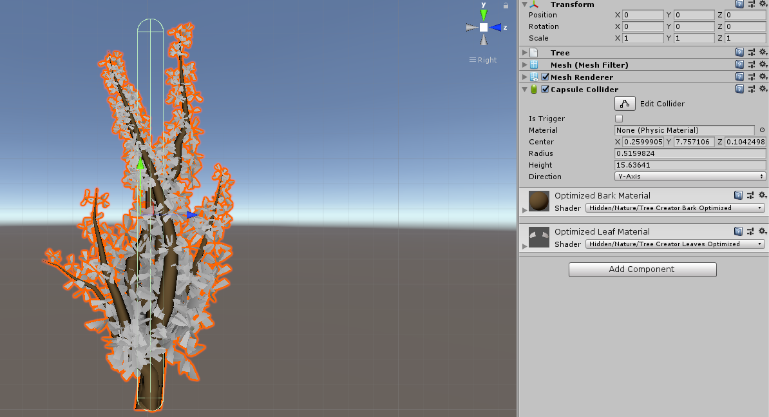

Figure 63 Defense task light settings

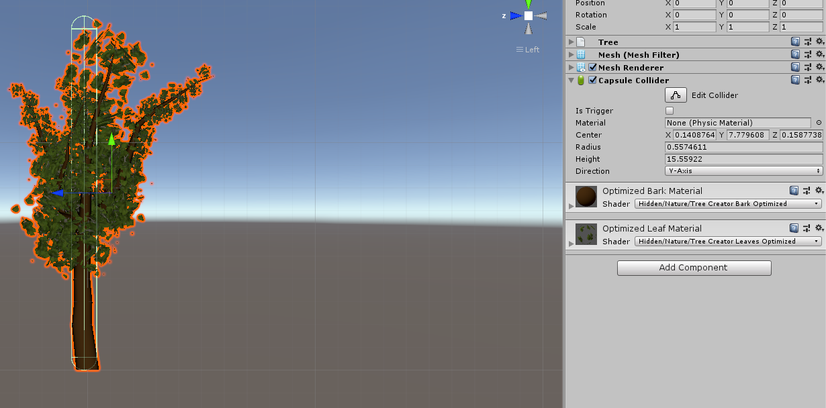

Figure 64 Defense task light settings

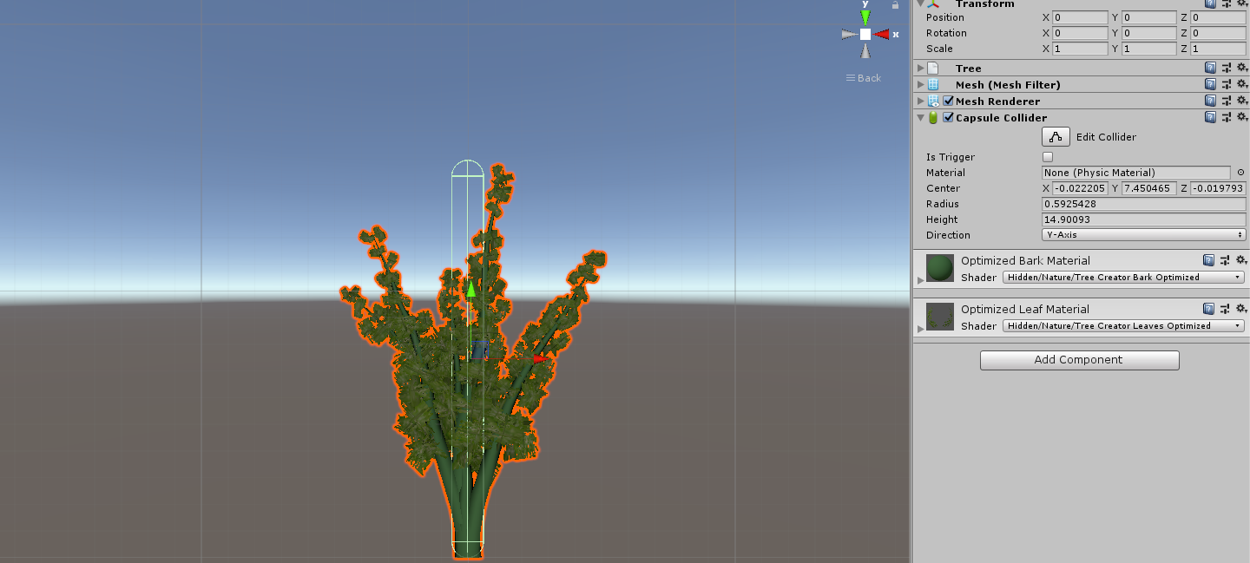

Figure 65 Defense task light settings

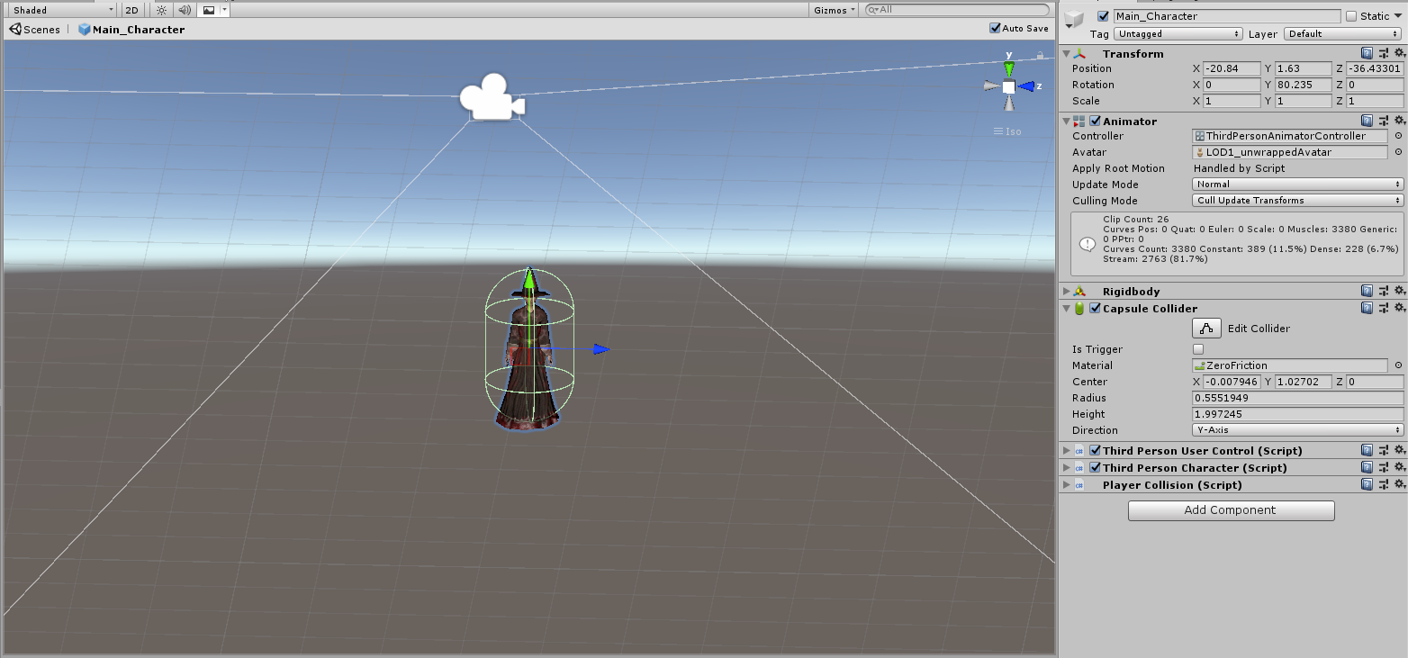

Figure 66 Defense task light settings

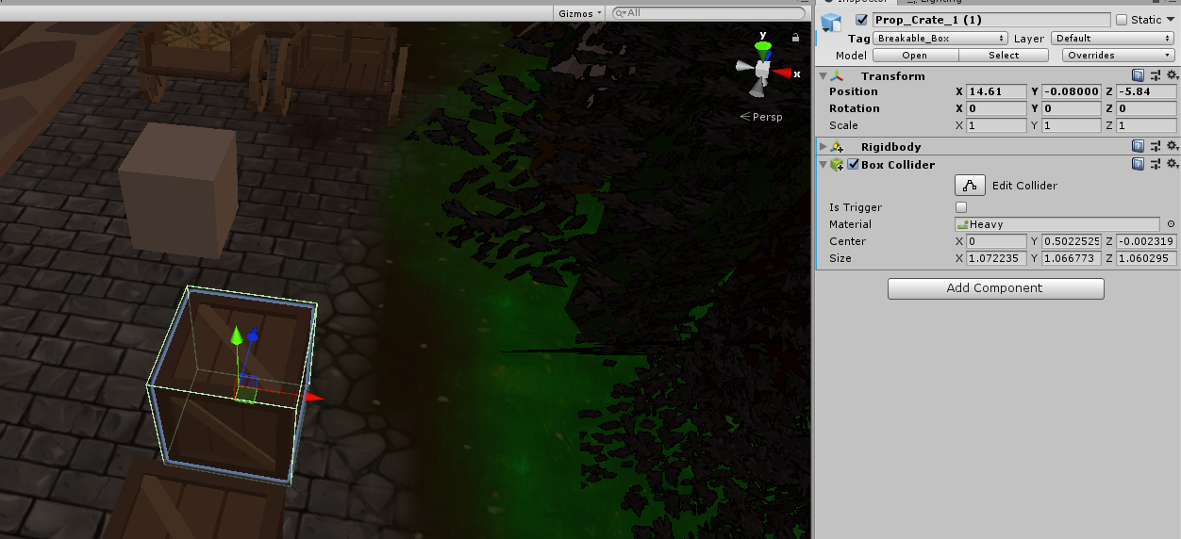

Figure 67 Defense task light settings

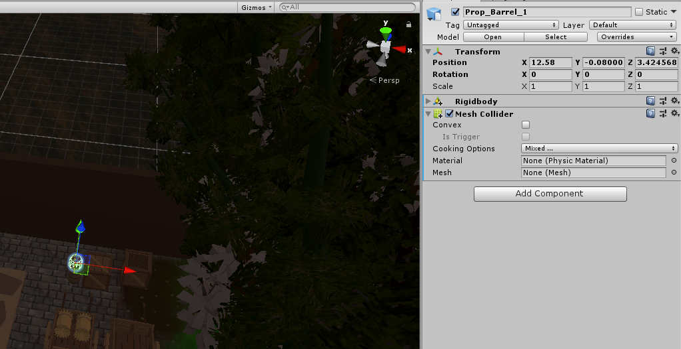

Figure 68 Defense task light settings

## **Task #9. *Add and animate 5 objects using PHYSICS, FORCE and TRIGGERS***

Description of the implementation (3-5 sentences).  *I added some objects from asset store, attached animators and animation controllers to all of them and then created 5 animations.*



Figure 69 Animation folder



Figure 70 Animated object



Figure 71 Animated object



Figure 72 Animated object



Figure 73 Animated object



Figure 74 Animated object



Figure 78 Block animation controller



Figure 79 Door 2 animation controller



Figure 80 Hay cart animation controller



Figure 81 Door animation controller

## **Task #10. *Set static flag to all immobile objects and measure batching performance***

Description of the implementation (3-5 sentences).  *I set static flags on all immobile objects. Making all objects static increased memory costs and building and batching time, but improved performance at runtime.*

**Task #11. *Try deferred vs forward rendering and measure performance for both***

Description of the implementation (3-5 sentences).  *I measured the performance when using deferred vs forward rendering method. Deferred rendering method is better when there are a lot of lights in scene, as the performance doesn’t change, while if you have only 1 light, using deferred method can hurt performance. Also deferred method can’t render transparent objects. The performance difference is 2-5fps.*

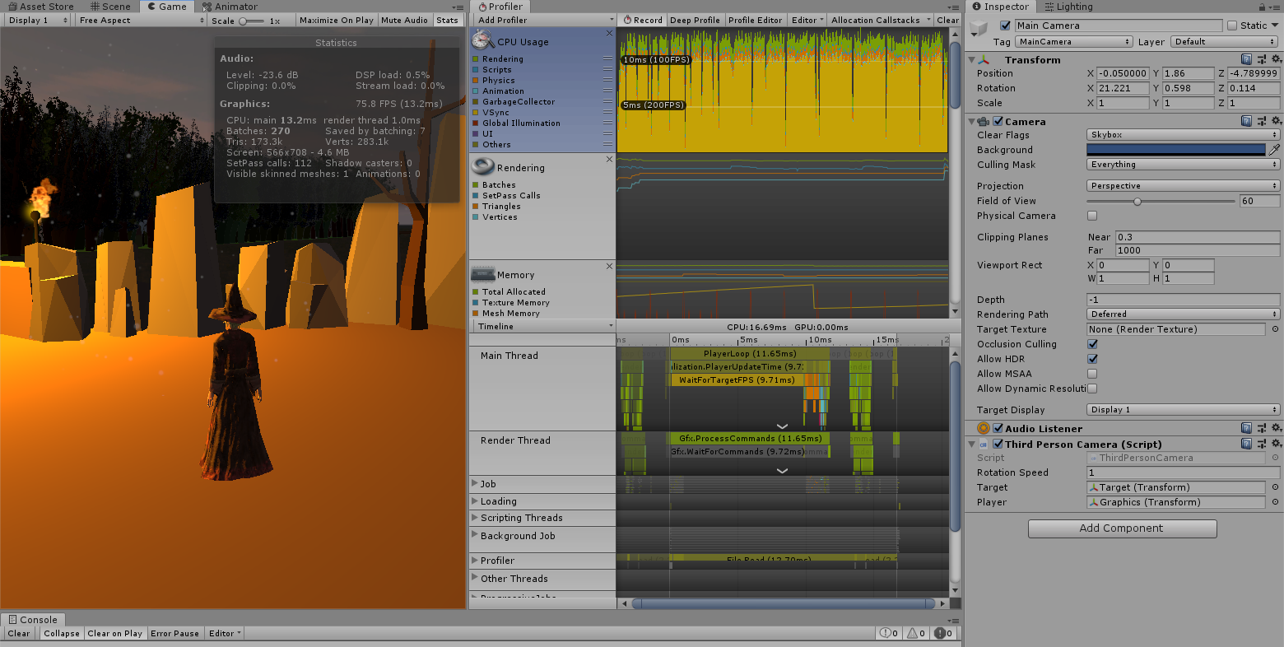

Figure 82 Performance when using deferred rendering method

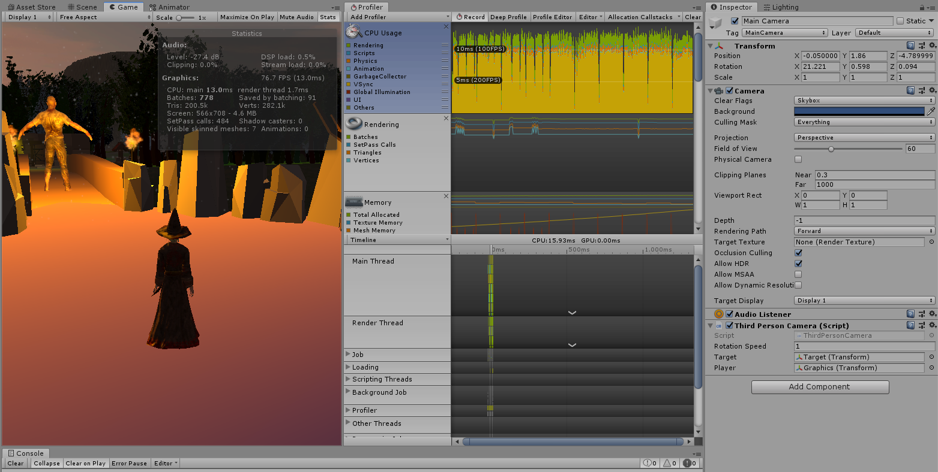

Figure 83 Performance when using forward rendering method

**Task #12. *Bake a lightmap for you scene and measure performance***

Description of the implementation (3-5 sentences).  *I turned lightmap baking on and set all lights to baked mode and instantly saw that my computer slowed down quite a bit while baking the lightmap, and it took a couple of minutes. I didn’t really see that big of a difference because I don’t use that much lights, but the slowdown while baking is quite noticeable. The performance difference is 3-6fps.*



Figure 84 Lightmap baking time

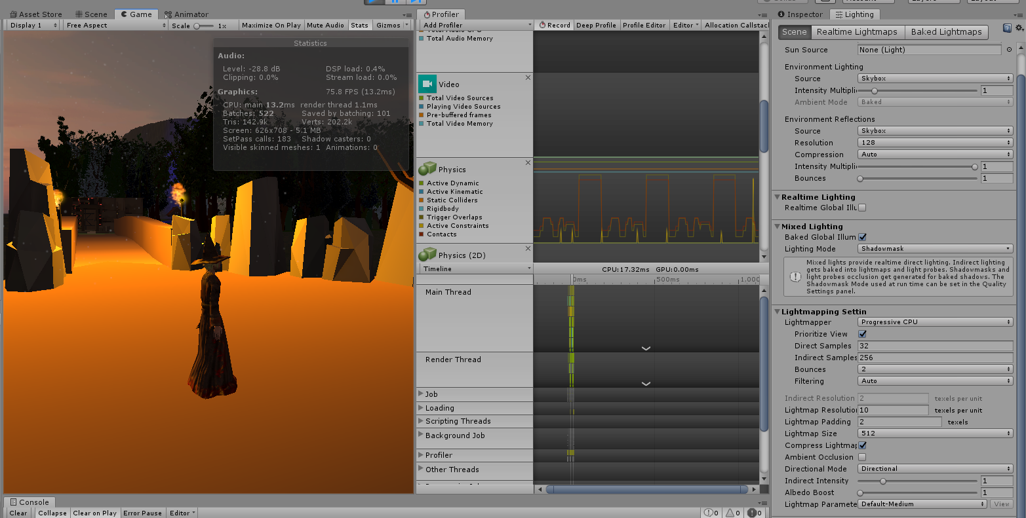

Figure 85 Performance when using baked lights and lightmap baking

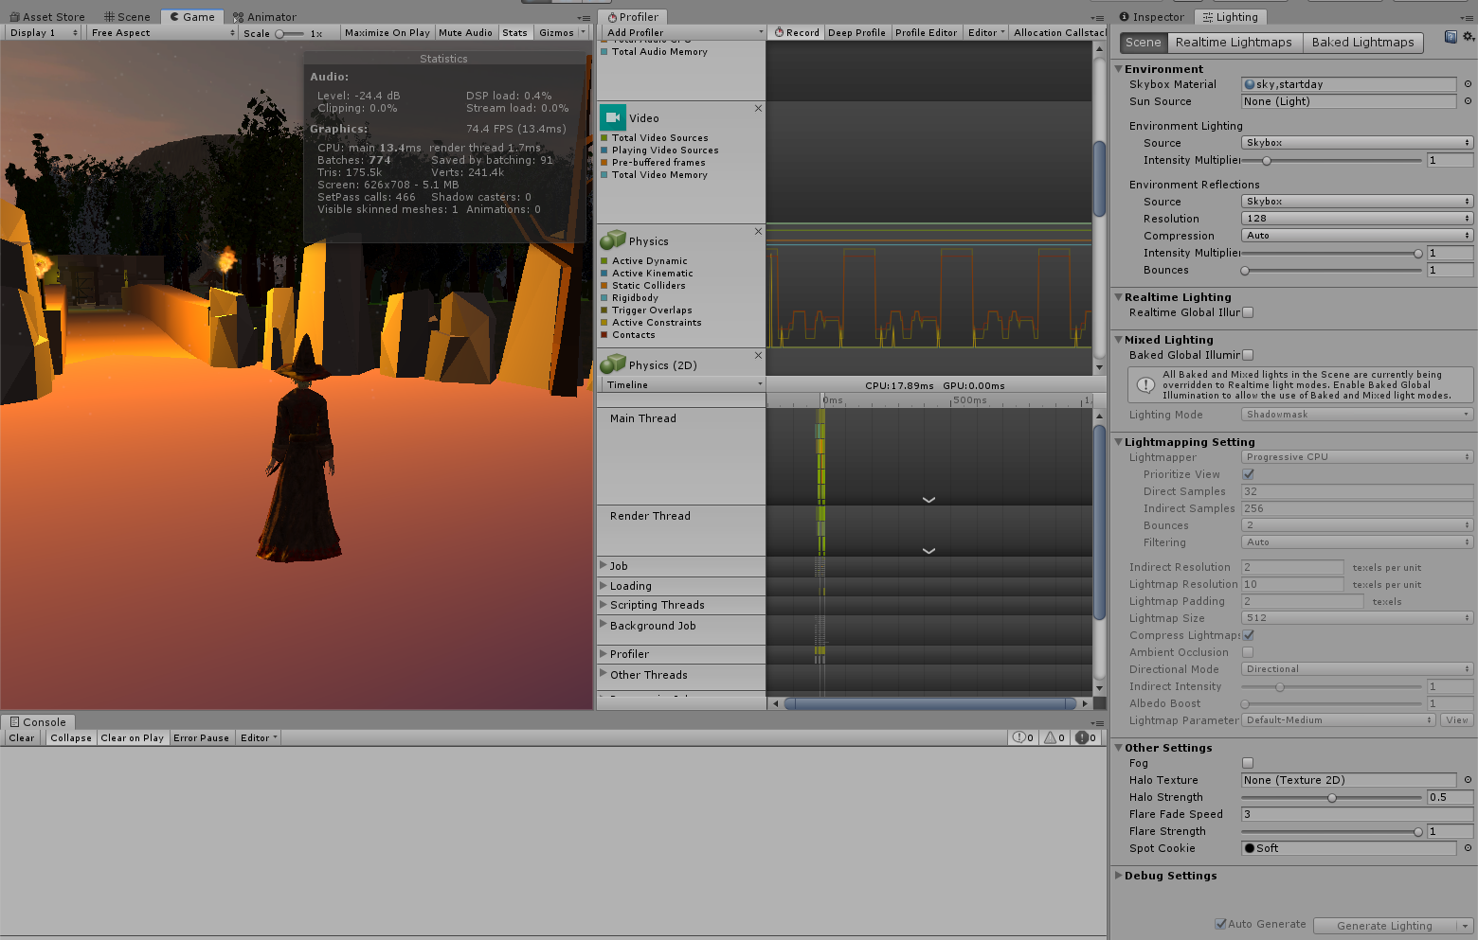

Figure 86 Performance when NOT using baked lights and lightmap baking

**Task #13. *Optimize all textures depending on their parameters and measure graphical memory load***

Description of the implementation (3-5 sentences).  *I turned on mipmaps on all textures. Performance wise it is useful to use mip maps on any 3D game as they make distant objects look better and use way less GPU memory.*

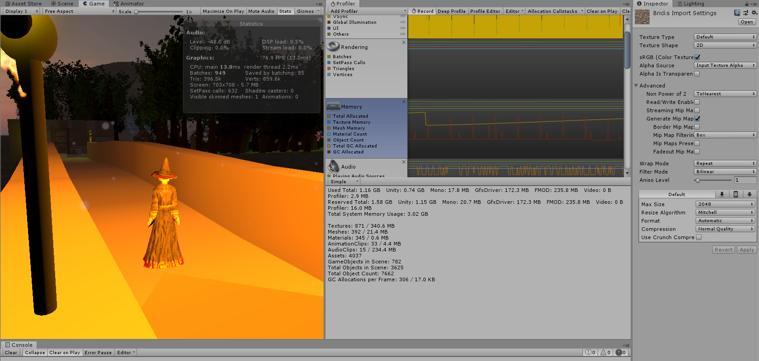

Figure 87 Used memory on textures

**Task #14. *Try hard vs soft shadows, different quality settings and measure the performance***

Description of the implementation (3-5 sentences).  *Firstly I turned all shadows to ultra quality soft and measured the performance, and then I did the same thing for hard shadows. The difference in performance between them wasn’t noticeable for me as I do not use lots of lights and my system is fairly powerful, but for older or weaker systems, turning down shadow resolution can change the performance drastically for the better. The performance difference is 3-5 fps.*

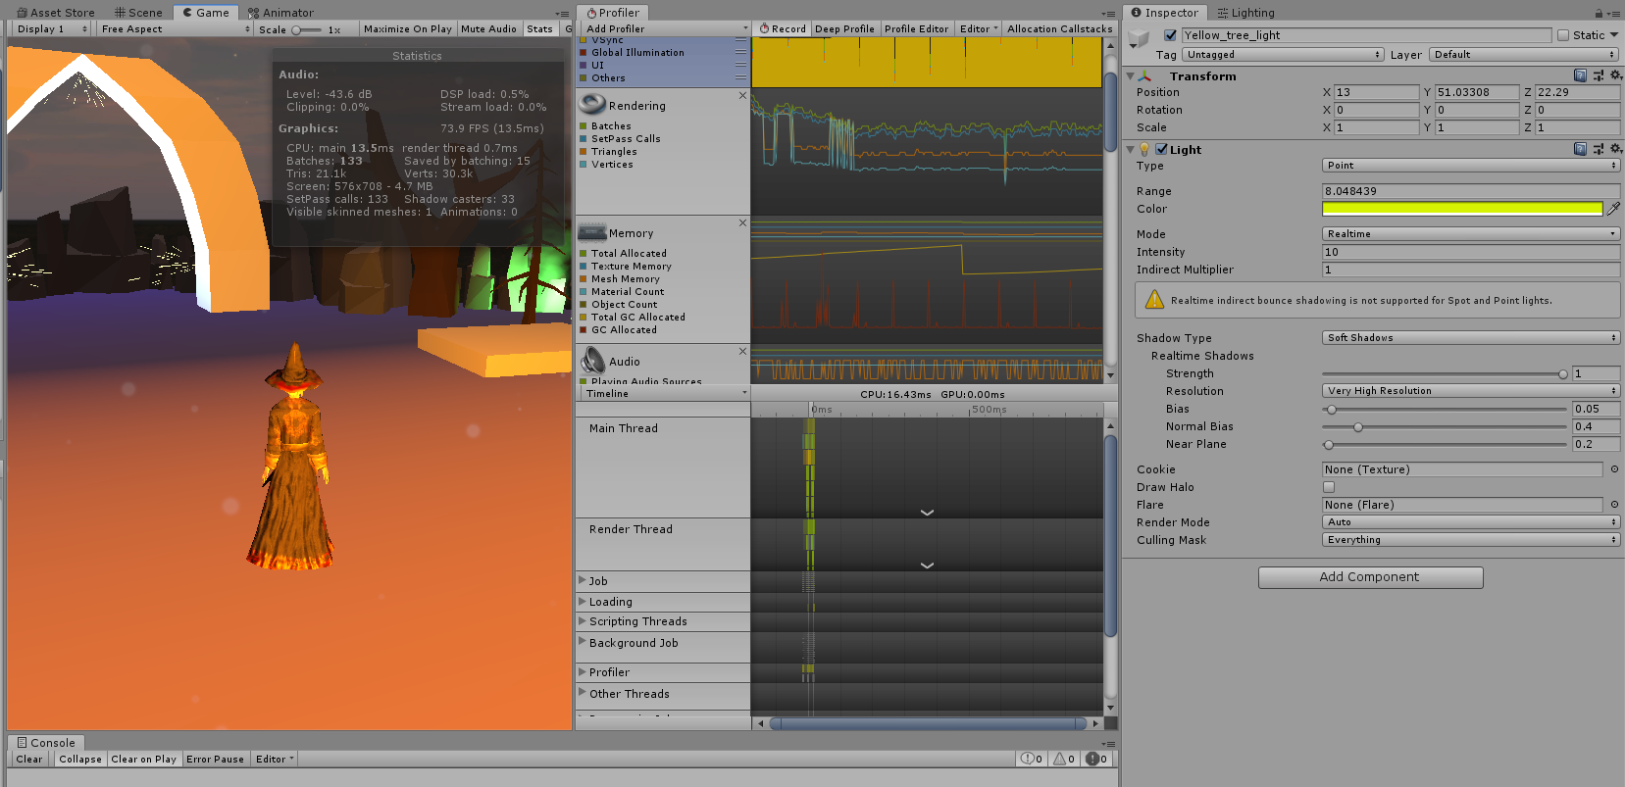

Figure 88 Performance while using ultra quality soft shadows

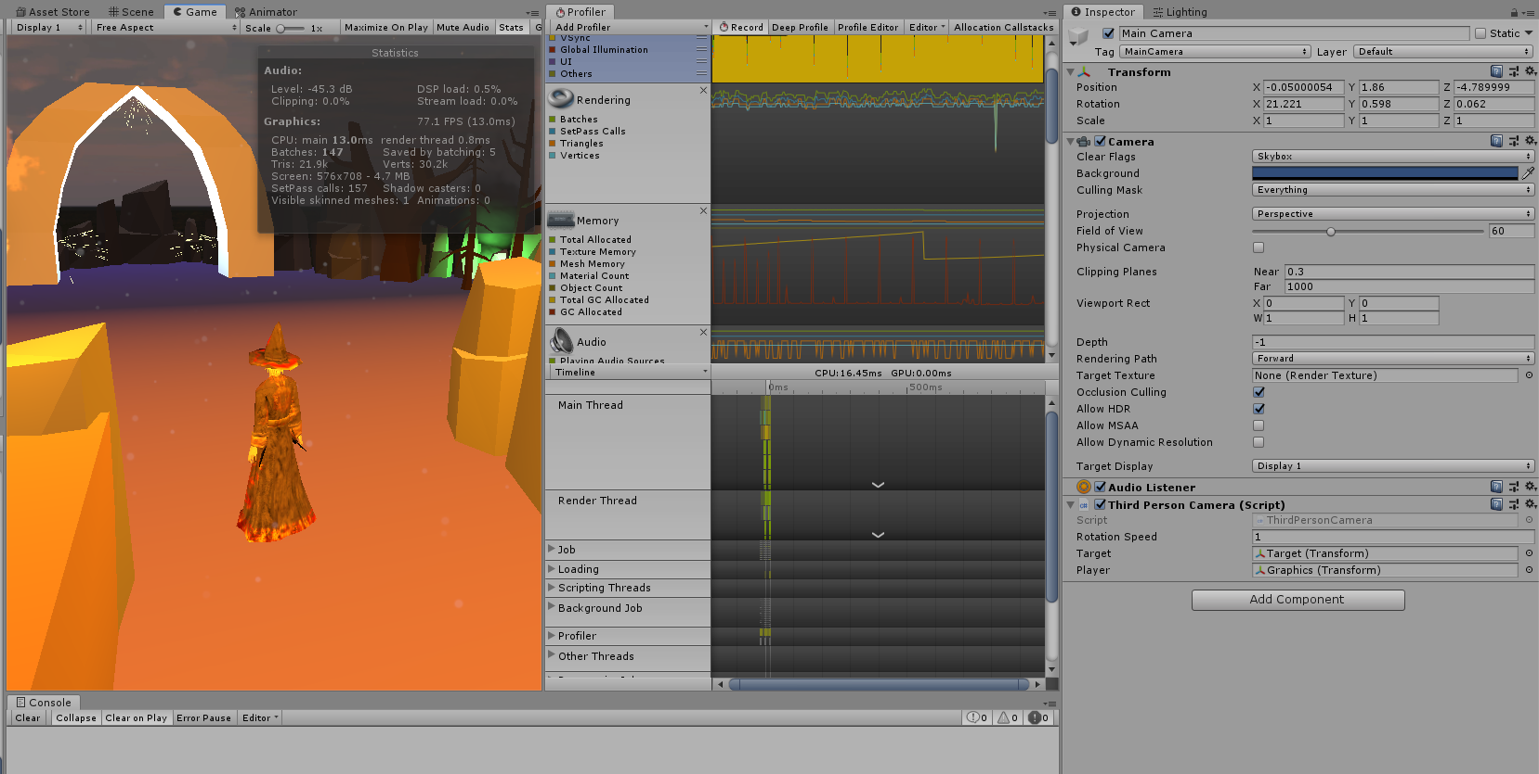

Figure 89 Performance while using hard shadows

# **Defence task**

Move character into the air when it enters cube‘s trigger.

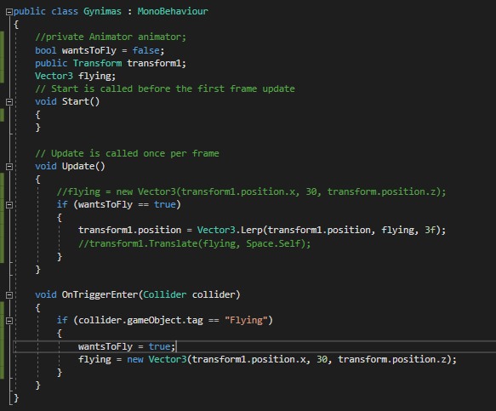

Figure 90 Script used to move character into the air when he collides with cubes trigger.

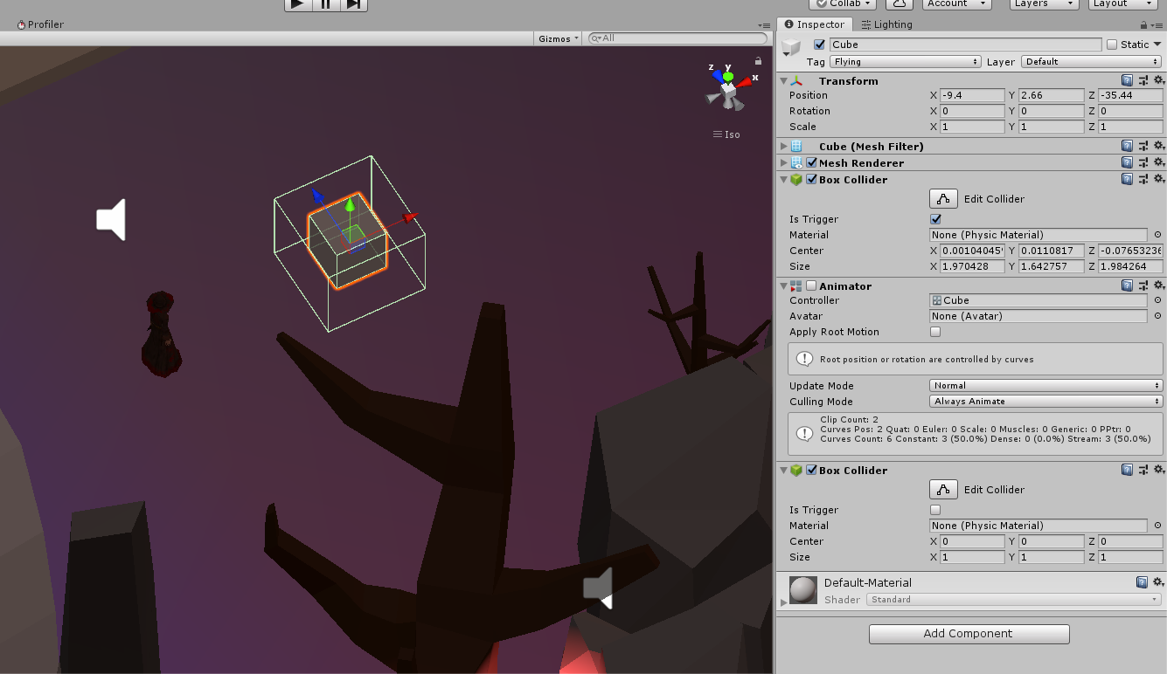

Figure 91 Cube with trigger attached to it.

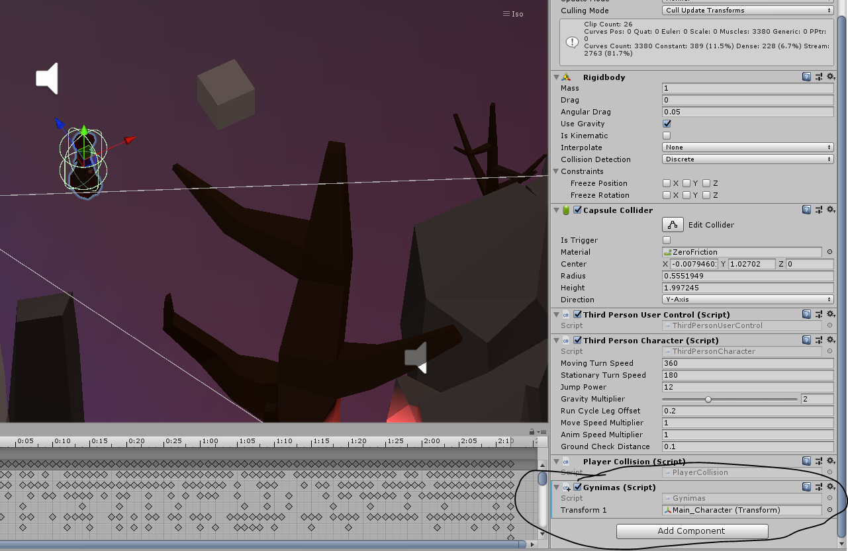

Figure 92 Main character with Gynimas script attached to it.

# **Laboratory work #3**

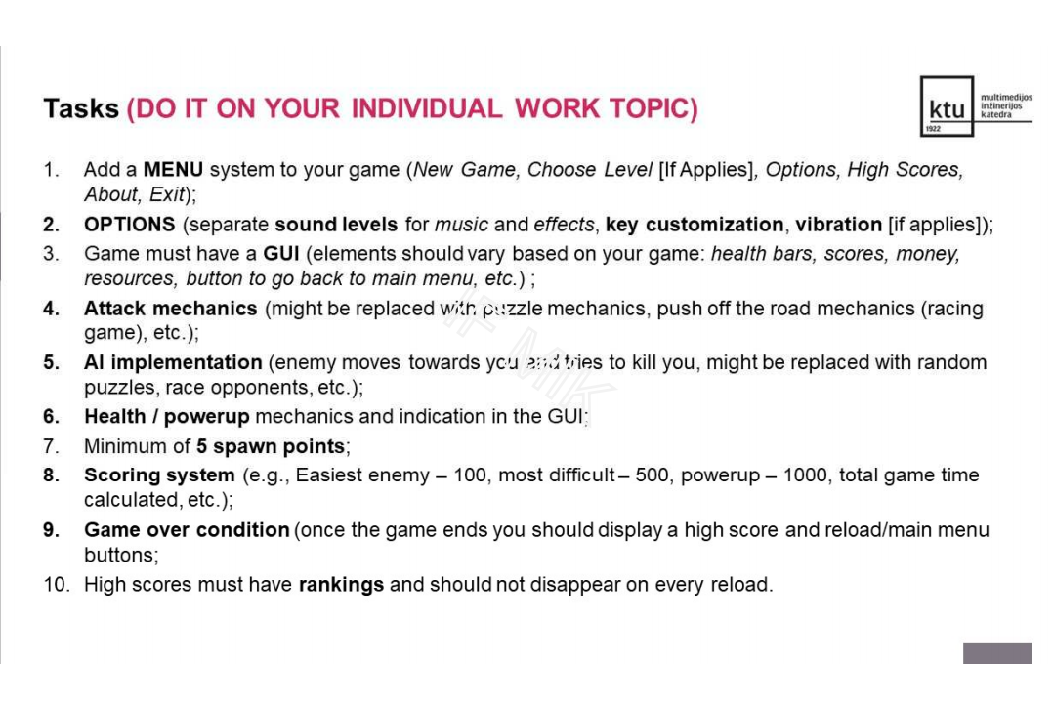

Figure 93 Laboratory work 3 task list

# **Solution**

## **Task #1. *Add a MENU system to your game***

Description of the implementation (3-5 sentences).  *Firstly, I created an empty canvas, then I added some buttons and text elements to it. Later I added some expanded functionality to those buttons.*

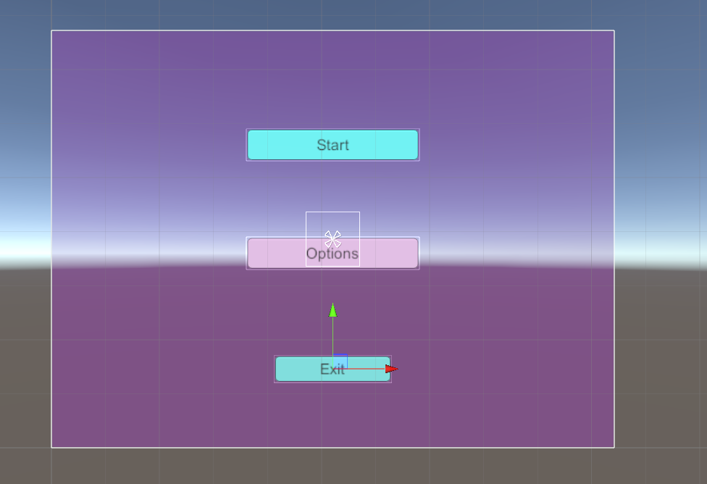

Figure 94 Menu screen

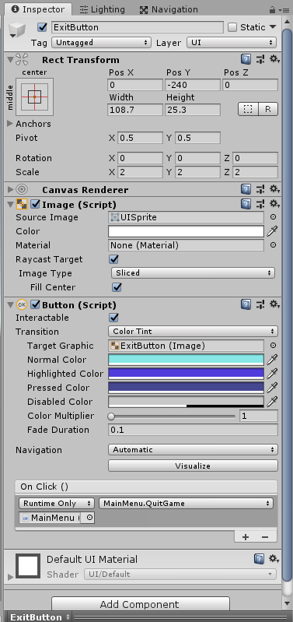

Figure 95 ExitButton properties

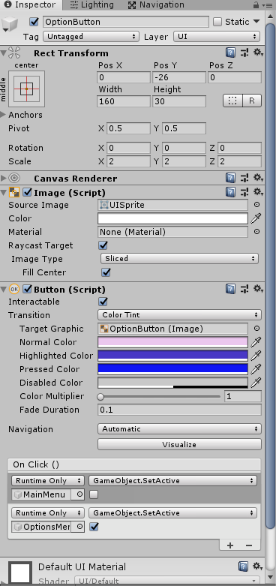

Figure 96 OptionButton properties

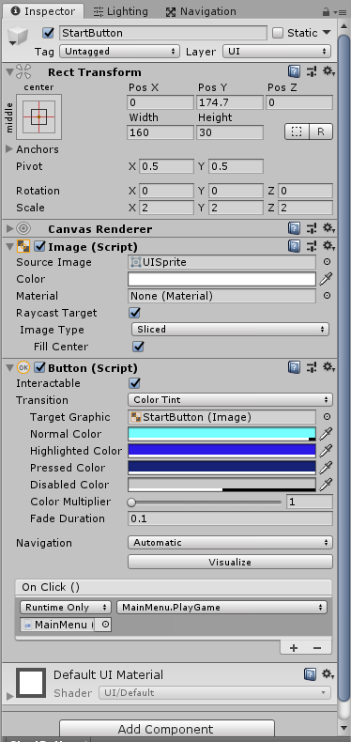

Figure 97 StartButton properties

## **Task #2. *Options***

Description of the implementation (3-5 sentences).  *I created an options menu, added 2 sliders and a back button to it. Then I created a sound mixer to control various sounds.*

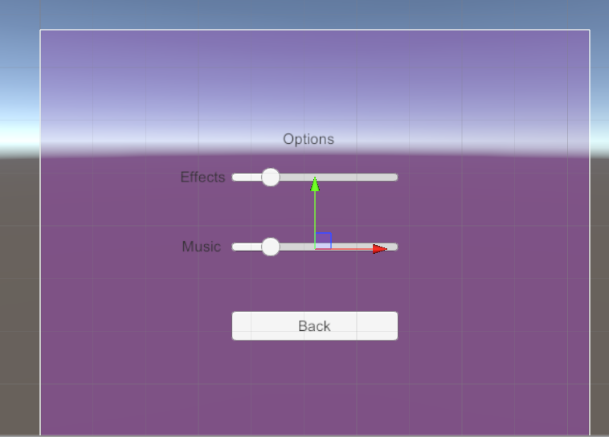

Figure 98 options menu

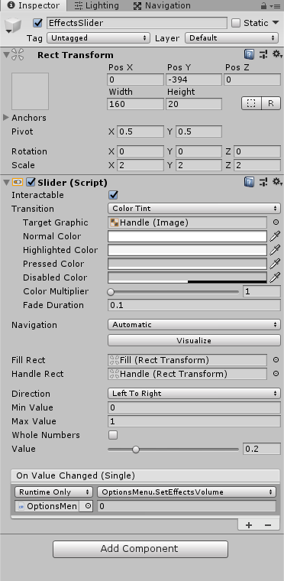

Figure 99 Effects slider properties

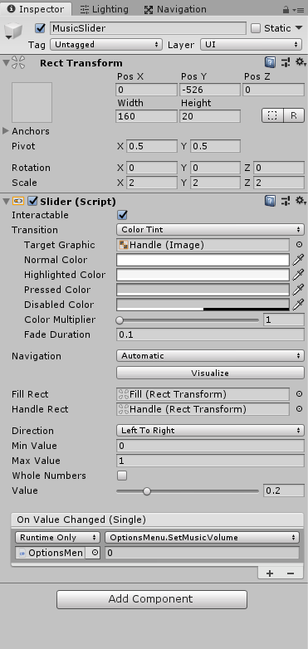

Figure 99 Music slider properties

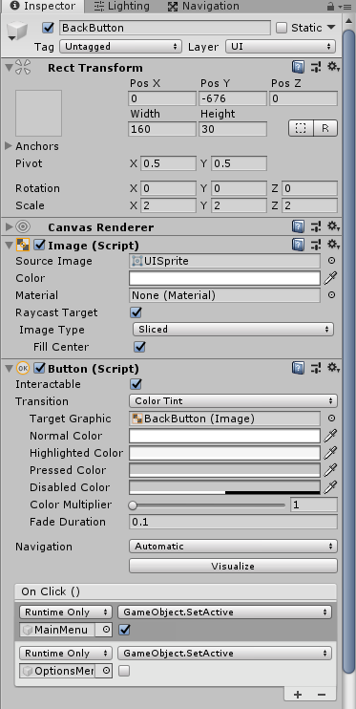

Figure 100 Back button properties

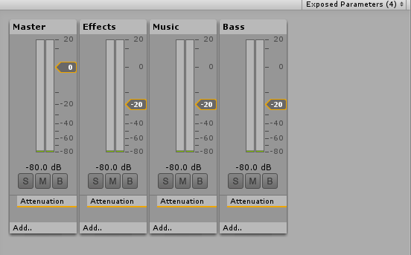

Figure 101 SoundMixer

## **Task #3. *Game must have a GUI***

Description of the implementation (3-5 sentences).  *I created an empty canvas and added a lot of different text elements to it.*

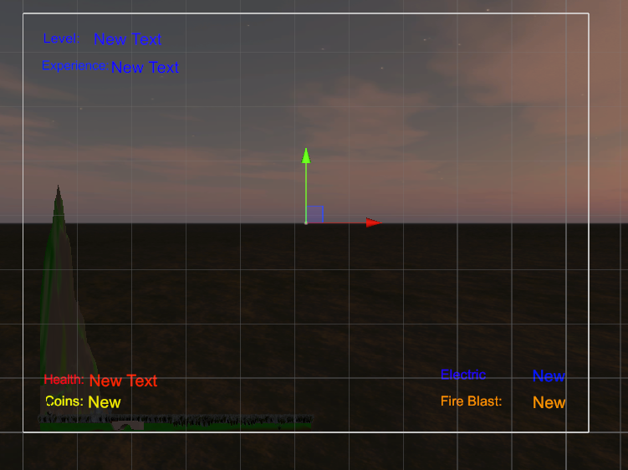

Figure 102 GUI screen

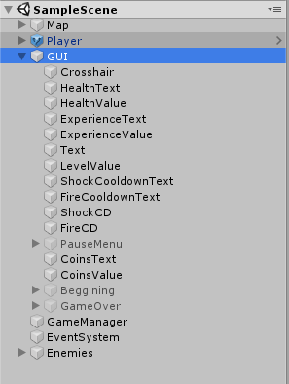

Figure 103 GUI hierarchy

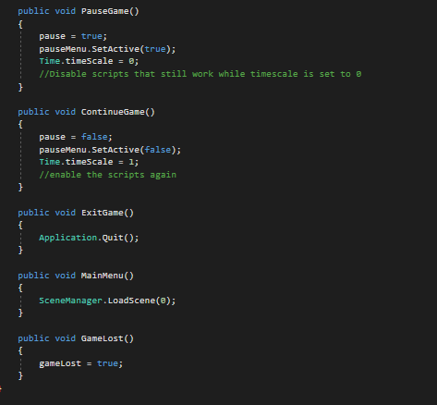

Figure 104 GUI Script

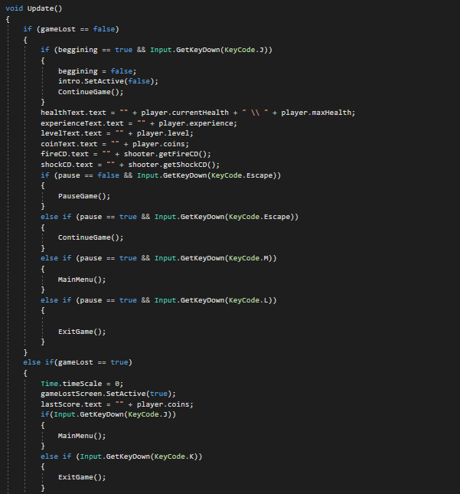

Figure 105 GUI script no.2

## **Task #4. *Attack mechanics***

Description of the implementation (3-5 sentences). I created some scripts and attached them to my main character. I also created some scripts for my enemies, so they could deal damage to me.

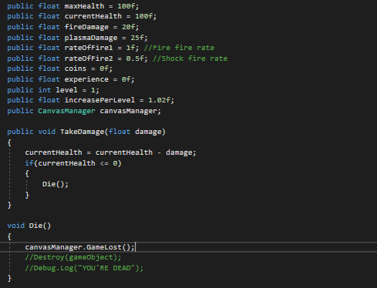

Figure 106 Attack mechanics script no. 1

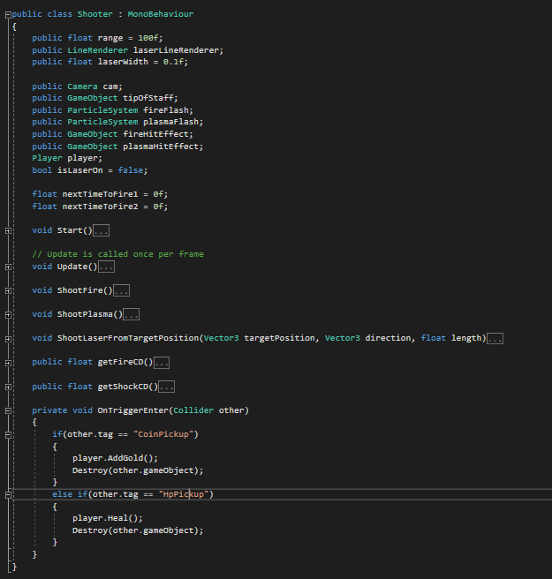

Figure 107 Attack script no. 2

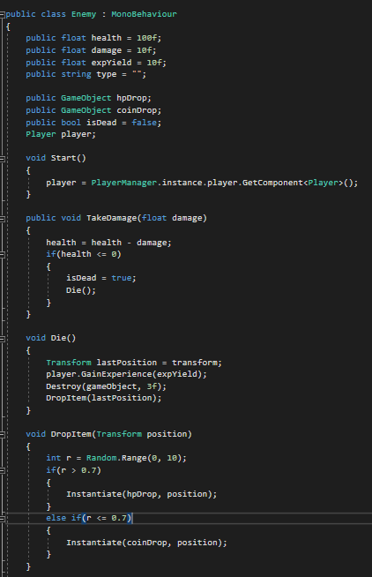

Figure 108 Attack script no. 3

## **Task #5. *AI implementation***

Description of the implementation (3-5 sentences).  *I created a simple AI which follows my character when it enters a certain range and then tries to kill it.*

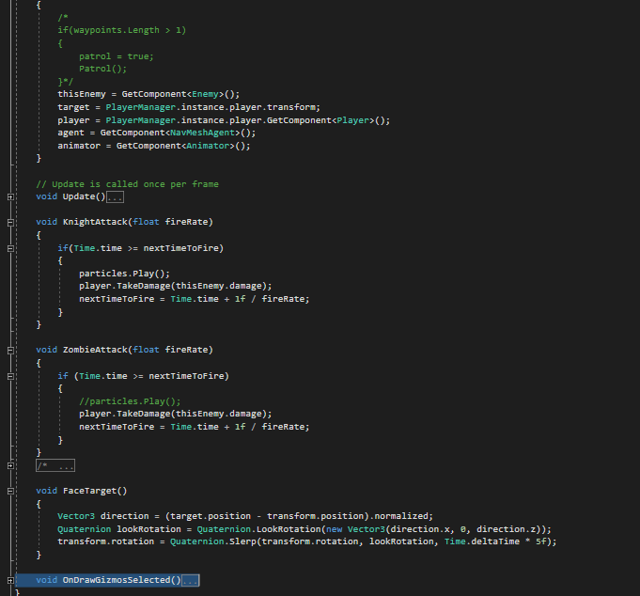

Figure 108 AI script

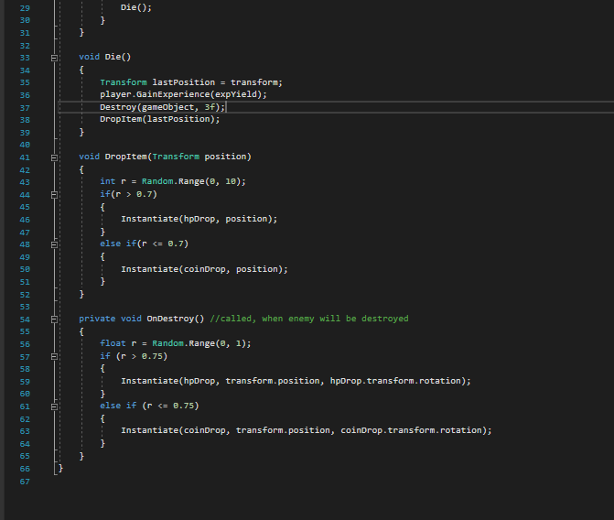

Figure 109 AI script 2

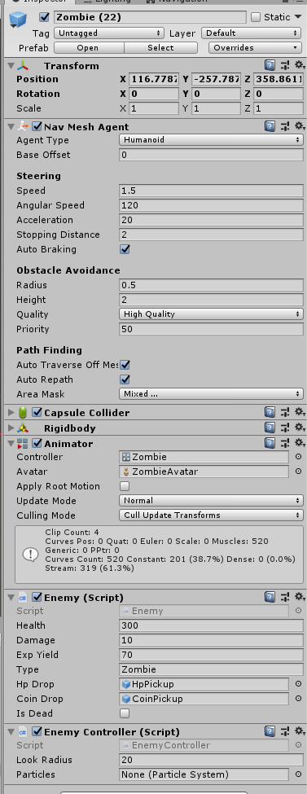

Figure 110 Zombie AI prefab properties

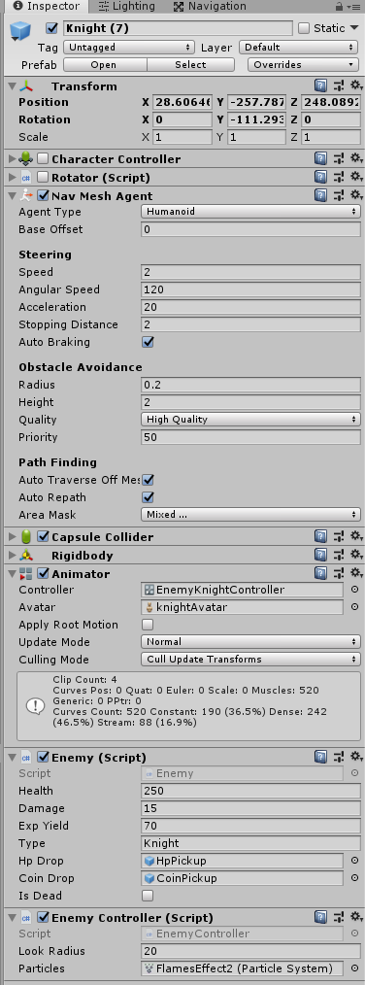

Figure 111 Knight AI prefab properties

## **Task #6. Health / powerup**

Description of the implementation (3-5 sentences).  *I added health, coins, health potions and other stuff.*

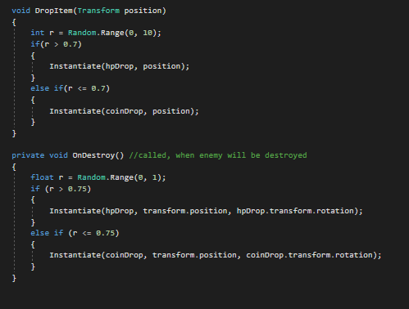

Figure 112 Item dropping script

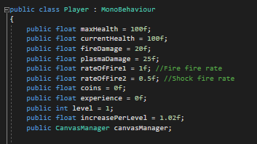

Figure 113 Player properties

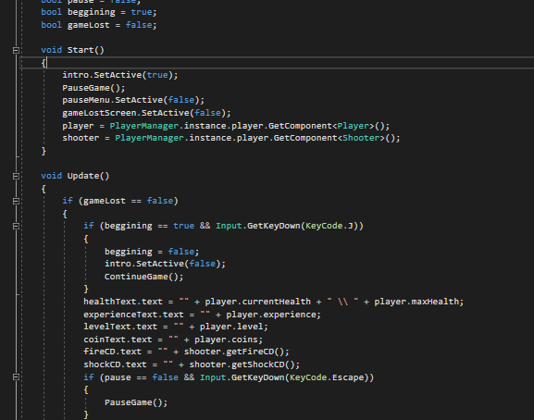

Figure 114 GUI update method

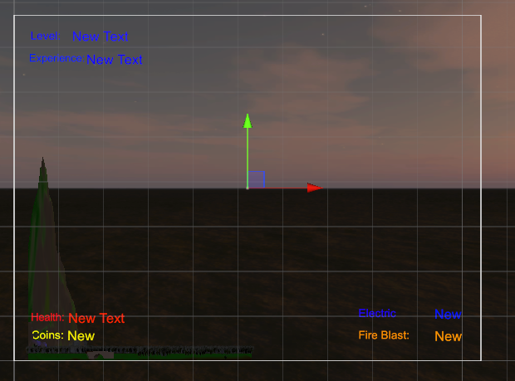

Figure 115 Player properties in GUI

## **Task #7. *Minimum of 5 spawn points***

Description of the implementation (3-5 sentences).  *I didn’t complete this task.*

## **Task #8. *Scoring system***

Description of the implementation (3-5 sentences).  *I created coins, which are my score.*

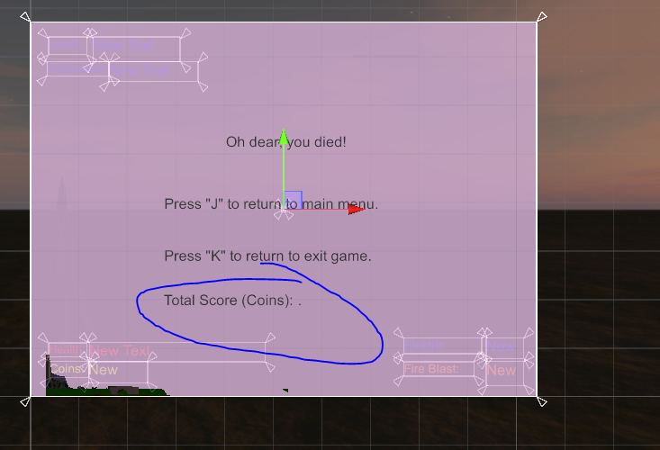

Figure 116 Coins shown in Death screen

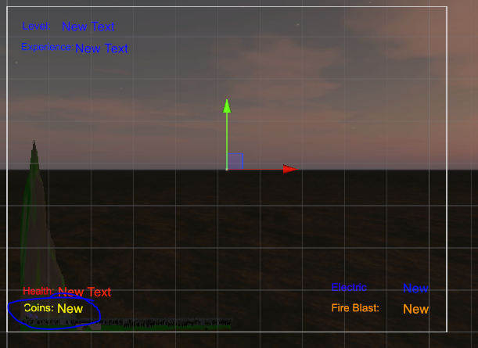

Figure 117 Coins shown on GUI

## **Task #9. *Game over condition***

Description of the implementation (3-5 sentences).  *Once my players health reaches 0, the game ends and the score (coins) is displayed. After that the player can choose to exit the game or return to main menu to restart the game.*

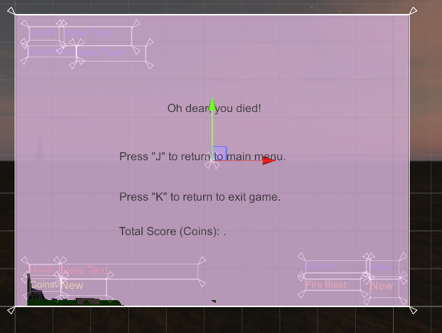

Figure 118 Game over screen

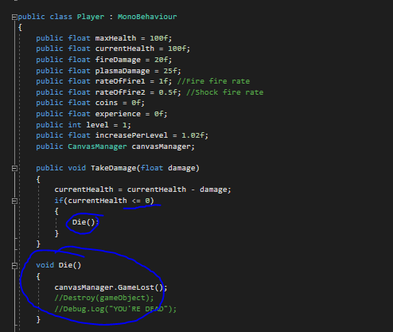

Figure 119 Game over condition

## **Task #10. *High scores must have rankings and should not disappear after reloading***

Description of the implementation (3-5 sentences). I didn’t impelement this task, because my game is not the kind of game that has hiscores.

# **Literature list**

1. Source #1. [*https://freesound.org/*](https://freesound.org/)
2. Source #2. <https://www.youtube.com/watch?v=7nxpDwnU0uU&list=PLrbglElPxW9KvfHztR-8UcZUX0h4jwdgE&index=2&t=0s>
3. Source #3 <https://www.youtube.com/watch?v=JYj6e-72RDs&index=2&list=PLrbglElPxW9KvfHztR-8UcZUX0h4jwdgE>
4. Source #4 <https://www.youtube.com/watch?v=Wql4nZkqG0g&list=PLrbglElPxW9KvfHztR-8UcZUX0h4jwdgE&index=3>
5. Source #5 <https://www.youtube.com/watch?v=69AlA-i1hIU&index=4&list=PLrbglElPxW9KvfHztR-8UcZUX0h4jwdgE>
6. <https://www.youtube.com/watch?v=THnivyG0Mvo>
7. <https://assetstore.unity.com/packages/3d/characters/humanoids/zombie-30232>
8. <https://assetstore.unity.com/packages/3d/animations/huge-fbx-mocap-library-part-3-20285>
9. <https://assetstore.unity.com/packages/3d/animations/huge-fbx-mocap-library-part-2-20282>
10. <https://assetstore.unity.com/packages/3d/environments/fantasy/mega-fantasy-props-pack-87811>
11. <https://assetstore.unity.com/packages/3d/animations/huge-fbx-mocap-library-part-1-19991>
12. <https://assetstore.unity.com/packages/3d/props/weapons/staff-of-pain-48820>
13. <https://assetstore.unity.com/packages/3d/characters/humanoids/modern-zombie-free-58134>
14. <https://assetstore.unity.com/packages/3d/characters/humanoids/blood-mage-jonas-7004>
15. <https://assetstore.unity.com/packages/3d/characters/humanoids/strong-knight-83586>

# **ANNEX**

All source code is contained in this part.

CanvasManager.cs

using System.Collections;

using System.Collections.Generic;

using UnityEngine;

using UnityEngine.SceneManagement;

using UnityEngine.UI;

public class CanvasManager : MonoBehaviour

{

public Text healthText;

public Text experienceText;

public Text levelText;

public Text coinText;

public Text shockCD;

public Text fireCD;

public Text lastScore;

public GameObject pauseMenu;

public GameObject intro;

public GameObject gameLostScreen;

Player player;

Shooter shooter;

bool pause = false;

bool beggining = true;

bool gameLost = false;

void Start()

{

intro.SetActive(true);

PauseGame();

pauseMenu.SetActive(false);

gameLostScreen.SetActive(false);

player = PlayerManager.instance.player.GetComponent<Player>();

shooter = PlayerManager.instance.player.GetComponent<Shooter>();

}

void Update()

{

if (gameLost == false)

{

if (beggining == true && Input.GetKeyDown(KeyCode.J))

{

beggining = false;

intro.SetActive(false);

ContinueGame();

}

healthText.text = "" + player.currentHealth + " \\ " + player.maxHealth;

experienceText.text = "" + player.experience;

levelText.text = "" + player.level;

coinText.text = "" + player.coins;

fireCD.text = "" + shooter.getFireCD();

shockCD.text = "" + shooter.getShockCD();

if (pause == false && Input.GetKeyDown(KeyCode.Escape))

{

PauseGame();

}

else if (pause == true && Input.GetKeyDown(KeyCode.Escape))

{

ContinueGame();

}

else if (pause == true && Input.GetKeyDown(KeyCode.M))

{

MainMenu();

}

else if (pause == true && Input.GetKeyDown(KeyCode.L))

{

ExitGame();

}

}

else if(gameLost == true)

{

Time.timeScale = 0;

gameLostScreen.SetActive(true);

lastScore.text = "" + player.coins;

if(Input.GetKeyDown(KeyCode.J))

{

MainMenu();

}

else if (Input.GetKeyDown(KeyCode.K))

{

ExitGame();

}

}

}

public void PauseGame()

{

pause = true;

pauseMenu.SetActive(true);

Time.timeScale = 0;

//Disable scripts that still work while timescale is set to 0

}

public void ContinueGame()

{

pause = false;

pauseMenu.SetActive(false);

Time.timeScale = 1;

//enable the scripts again

}

public void ExitGame()

{

Application.Quit();

}

public void MainMenu()

{

SceneManager.LoadScene(0);

}

public void GameLost()

{

gameLost = true;

}

}

Player.cs

using System.Collections;

using System.Collections.Generic;

using UnityEngine;

public class Player : MonoBehaviour

{

public float maxHealth = 100f;

public float currentHealth = 100f;

public float fireDamage = 20f;

public float plasmaDamage = 25f;

public float rateOfFire1 = 1f; //Fire fire rate

public float rateOfFire2 = 0.5f; //Shock fire rate

public float coins = 0f;

public float experience = 0f;

public int level = 1;

public float increasePerLevel = 1.02f;

public CanvasManager canvasManager;

public void TakeDamage(float damage)

{

currentHealth = currentHealth - damage;

if(currentHealth <= 0)

{

Die();

}

}

void Die()

{

canvasManager.GameLost();

//Destroy(gameObject);

//Debug.Log("YOU'RE DEAD");

}

public void GainExperience(float experieneGain)

{

experience = experience + experieneGain;

if(experience % 100 == 0 || experience / level > 100)

{

LevelUp();

}

}

void LevelUp()

{

level = level + 1;

maxHealth = maxHealth * increasePerLevel;

fireDamage = fireDamage * increasePerLevel;

plasmaDamage = plasmaDamage * increasePerLevel;

currentHealth = maxHealth;

}

public void Heal()

{

float r = Random.Range(20, 60);

currentHealth = currentHealth + r;

}

public void AddGold()

{

float r = Random.Range(0, 150);

coins = coins + r;

}

}

Shooter.cs

using UnityEngine;

public class Shooter : MonoBehaviour

{

public float range = 100f;

public LineRenderer laserLineRenderer;

public float laserWidth = 0.1f;

public Camera cam;

public GameObject tipOfStaff;

public ParticleSystem fireFlash;

public ParticleSystem plasmaFlash;

public GameObject fireHitEffect;

public GameObject plasmaHitEffect;

Player player;

bool isLaserOn = false;

float nextTimeToFire1 = 0f;

float nextTimeToFire2 = 0f;

void Start()

{

player = GetComponent<Player>();

Vector3[] initLaserPositions = new Vector3[2] { Vector3.zero, Vector3.zero };

laserLineRenderer.SetPositions(initLaserPositions);

laserLineRenderer.startWidth = laserWidth;

laserLineRenderer.endWidth = laserWidth;

}

// Update is called once per frame

void Update()

{

ShootLaserFromTargetPosition(tipOfStaff.transform.position, cam.transform.forward, range);

if(Input.GetKeyDown(KeyCode.V))

{

if(isLaserOn == true)

{

isLaserOn = false;

}

else

{

isLaserOn = true;

}

}

if(isLaserOn == true)

{

laserLineRenderer.enabled = true;

}

else

{

laserLineRenderer.enabled = false;

}

if (Input.GetButtonDown("Fire1"))

{

ShootFire();

}

if (Input.GetButtonDown("Fire2"))

{

ShootPlasma();

}

}

void ShootFire()

{

RaycastHit hit;

if (Time.time >= nextTimeToFire1)

{

fireFlash.Play();

if (Physics.Raycast(tipOfStaff.transform.position, cam.transform.forward, out hit, range))

{

Player player2 = hit.transform.GetComponent<Player>();

if(player2 == null)

{

Debug.Log(hit.transform.name);

Enemy enemy = hit.transform.GetComponent<Enemy>();

if(enemy != null)

{

if(enemy.type == "Knight")

{

Debug.Log("Attack is highly ineffective against a hell knight");

}

else

{

enemy.TakeDamage(player.fireDamage);

}

}

GameObject effect = Instantiate(fireHitEffect, hit.point, Quaternion.LookRotation(hit.normal));

Destroy(effect, 1f);

}

}

nextTimeToFire1 = Time.time + 1f / player.rateOfFire1;

}

}

void ShootPlasma()

{

RaycastHit hit;

if (Time.time >= nextTimeToFire2)

{

plasmaFlash.Play();

if (Physics.Raycast(tipOfStaff.transform.position, cam.transform.forward, out hit, range))

{

Player player2 = hit.transform.GetComponent<Player>();

if (player2 == null)

{

Debug.Log(hit.transform.name);

Enemy enemy = hit.transform.GetComponent<Enemy>();

if (enemy != null)

{

if (enemy.type == "Knight")

{

enemy.TakeDamage(player.plasmaDamage * 2);

}

else

{

enemy.TakeDamage(player.plasmaDamage);

}

}

GameObject effect = Instantiate(plasmaHitEffect, hit.point, Quaternion.LookRotation(hit.normal));

Destroy(effect, 1f);

}

}

nextTimeToFire2 = Time.time + 1f / player.rateOfFire2;

}

}

void ShootLaserFromTargetPosition(Vector3 targetPosition, Vector3 direction, float length)

{

Ray ray = new Ray(targetPosition, direction);

RaycastHit raycastHit;

Vector3 endPosition = targetPosition + (length * direction);

if (Physics.Raycast(ray, out raycastHit, length))

{

endPosition = raycastHit.point;

}

laserLineRenderer.SetPosition(0, targetPosition);

laserLineRenderer.SetPosition(1, endPosition);

}

public float getFireCD()

{

float r = nextTimeToFire1 - Time.time;

if (r < 0)

{

r = 0;

}

return r;

}

public float getShockCD()

{

float r = nextTimeToFire2 - Time.time;

if(r < 0)

{

r = 0;

}

return r;

}

private void OnTriggerEnter(Collider other)

{

if(other.tag == "CoinPickup")

{

player.AddGold();

Destroy(other.gameObject);

}

else if(other.tag == "HpPickup")

{

player.Heal();

Destroy(other.gameObject);

}

}

}

Enemy.cs

using System.Collections;

using System.Collections.Generic;

using UnityEngine;

using UnityEngine.AI;

public class Enemy : MonoBehaviour

{

public float health = 100f;

public float damage = 10f;

public float expYield = 10f;

public string type = "";

public GameObject hpDrop;

public GameObject coinDrop;

public bool isDead = false;

Player player;

void Start()

{

player = PlayerManager.instance.player.GetComponent<Player>();

}

public void TakeDamage(float damage)

{

health = health - damage;

if(health <= 0)

{

isDead = true;

Die();

}

}

void Die()

{

Transform lastPosition = transform;

player.GainExperience(expYield);

Destroy(gameObject, 3f);

DropItem(lastPosition);

}

void DropItem(Transform position)

{

int r = Random.Range(0, 10);

if(r > 0.7)

{

Instantiate(hpDrop, position);

}

else if(r <= 0.7)

{

Instantiate(coinDrop, position);

}

}

private void OnDestroy() //called, when enemy will be destroyed

{

float r = Random.Range(0, 1);

if (r > 0.75)

{

Instantiate(hpDrop, transform.position, hpDrop.transform.rotation);

}

else if (r <= 0.75)

{

Instantiate(coinDrop, transform.position, coinDrop.transform.rotation);

}

}

}

PlayerManager.cs

using System.Collections;

using System.Collections.Generic;

using UnityEngine;

public class PlayerManager : MonoBehaviour

{

#region Singleton

public static PlayerManager instance;

void Awake()

{

instance = this;

}

#endregion

public GameObject player;

}

EnemyController.cs

using System.Collections;

using System.Collections.Generic;

using UnityEngine;

using UnityEngine.AI;

public class EnemyController : MonoBehaviour

{

public float lookRadius = 10f;

public ParticleSystem particles; //For Hell Knight's flames

//public Transform[] waypoints;

float nextTimeToFire = 0f; //Cooldown between attacks

Enemy thisEnemy;

Player player;

Transform target;

NavMeshAgent agent;

Animator animator;

bool isChasing = false;

//bool patrol = false;

// Start is called before the first frame update

void Start()

{

/*

if(waypoints.Length > 1)

{

patrol = true;

Patrol();

}*/

thisEnemy = GetComponent<Enemy>();

target = PlayerManager.instance.player.transform;

player = PlayerManager.instance.player.GetComponent<Player>();

agent = GetComponent<NavMeshAgent>();

animator = GetComponent<Animator>();

}

// Update is called once per frame

void Update()

{

if (thisEnemy.isDead == false)

{

float distance = Vector3.Distance(target.position, transform.position);

if (distance <= lookRadius)

{

//patrol = false;

isChasing = true;

agent.SetDestination(target.position);

animator.SetBool("isChasing", true);

if (distance <= agent.stoppingDistance)

{

FaceTarget();

agent.isStopped = true;

animator.SetBool("inRange", true);

if (thisEnemy.type == "Knight")

{

KnightAttack(2f);

}

else if (thisEnemy.type == "Zombie")

{

ZombieAttack(2f);

}

//animator.SetBool("inRange", false);

//agent.isStopped = false;

}

else

{

agent.isStopped = false;

animator.SetBool("inRange", false);

animator.SetBool("isChasing", true);

}

}

else if (isChasing == true)

{

agent.SetDestination(target.position);

animator.SetBool("isChasing", true);

}

}

else if(thisEnemy.isDead == true)

{

agent.enabled = false;

animator.SetBool("isDead", true);

}

}

void KnightAttack(float fireRate)

{

if(Time.time >= nextTimeToFire)

{

particles.Play();

player.TakeDamage(thisEnemy.damage);

nextTimeToFire = Time.time + 1f / fireRate;

}

}

void ZombieAttack(float fireRate)

{

if (Time.time >= nextTimeToFire)

{

//particles.Play();

player.TakeDamage(thisEnemy.damage);

nextTimeToFire = Time.time + 1f / fireRate;

}

}

/*

void Patrol()

{

if(patrol == true)

{

Random rand = new Random();

int r = Random.Range(0, waypoints.Length);

}

}*/

void FaceTarget()

{

Vector3 direction = (target.position - transform.position).normalized;

Quaternion lookRotation = Quaternion.LookRotation(new Vector3(direction.x, 0, direction.z));

transform.rotation = Quaternion.Slerp(transform.rotation, lookRotation, Time.deltaTime * 5f);

}

void OnDrawGizmosSelected()

{

Gizmos.color = Color.red;

Gizmos.DrawWireSphere(transform.position, lookRadius);

}

}

MainMenu.cs

using System.Collections;

using System.Collections.Generic;

using UnityEngine;

using UnityEngine.SceneManagement;

public class MainMenu : MonoBehaviour

{

public void PlayGame()

{

SceneManager.LoadScene(SceneManager.GetActiveScene().buildIndex + 1);

}

public void QuitGame()

{

Debug.Log("Quit");

Application.Quit();

}

}